Collaborative Approach to Public Good Investment (CAPGI) Feasibility Study: Final Report and Lessons Learned

by

Len M. Nichols, Lauren A. Taylor, George Miller, Corwin Rhyan³,
Paul Hughes-Cromwick3, Ani Turner³, and Richard M. Hamrick III

for

Commonwealth Fund, Missouri Foundation for Health, Episcopal Health Foundation, and California Health Care Foundation

May 20, 2020
Table of Contents

Executive Summary 3
Project Plan and Overview 6
Partners 6
Spreading the Word About the Feasibility Study 7
Webinars 7
Site Selection 8
Site Visits 10
Readiness Assessments 14
Tools for Future Practitioners of Collaborative Financing 16
Conclusions and Lessons Learned 17
Appendix 1: Community Coalition Checklist 22
Appendix 2: Specific Site Visit Outcome Summaries 24
Appendix 3: CAPGI Site Status and Readiness Gaps 32
Appendix 4: Business Case Templates CAPGI EXCEL Attachment #1
Appendix 5: Data Flow Maps 36
Appendix 6: Bibliography 42
Appendix 7: Scenarios for sharing CAPGI with private investors CAPGI EXCEL Attachment #2
Collaborative Approach to Public Goods Investment (CAPGI) Feasibility Study:
Final Report and Lessons Learned

EXECUTIVE SUMMARY
The purpose of this project was to determine if a collaborative approach to financing social determinants of health (SDOH) interventions is feasible in actual communities in the United States. Nichols and Taylor’s Health Affairs paper (August 2018) was based on the assertion that what economists call the “free rider problem” was partly responsible for the chronic underinvestment in key services that are upstream from the health care system but are desperately needed. Large bodies of research have demonstrated that social determinant deficits lead to undesirable health and social outcomes. Our contribution was to show that an economic model, derived from earlier work and adapted for the SDOH context, could help communities solve specific free rider problems and unleash more investment that could sustainably improve lives and lower costs as well. The question of this feasibility project was whether, in the real world, our theoretical model and suggested processes could attract sufficient interest to merit implementation technical assistance funding and effort.
We have been fortunate to have a series of excellent partners supporting us in the work. Each funder – the Commonwealth Fund, the Missouri Foundation for Health, the Episcopal Health Foundation and the California Health Care Foundation –had experience funding upstream work and understood both the potential and the pitfalls of implementing novel models like ours. They also helped us to select a stellar Advisory Committee that guided us wisely when we needed it most. Our CAPGI Team, all co-authors of this report, combined knowledge, skills and experience that complemented each other’s and enabled us to learn enough in real time to keep the project moving forward despite the predictable hiccups and the onset of Covid-19.
Our paper generated more “real world” interest than is normally elicited from a peer-reviewed publication with theoretical economic content. This interest manifested in unexpectedly large attendance in four 90-minute webinars designed to teach the model and processes held in July and September of 2019. We were gratified to see between 210 and 287 participants, from as many as 90 counties from Alaska to Massachusetts. After the webinars, we invited submissions of our Community Coalition Checklist (Appendix 1), which helped us assess the maturity and breadth of groups. Twenty-three communities submitted completed checklists, which we then augmented with publicly available data related to SDOH landscapes, economic structures and demographic compositions. Our Funders and Advisory Committee gathered with us in October to discuss the variation among those interested and criteria that might help us rank them by likelihood of succeeding with a CAPGI project. In the end, we selected 11 sites for visiting, and scheduled them from January – April 2020.
We completed five 2-day visits and one 1-day visit before Covid-19 stopped travel and forced many health as well as social service front line organizations to focus more on immediate concerns than novel SDOH financing mechanisms. We were able to engage four other sites virtually in a variety of ways, and conduct follow-up conversations in all communities as well, so we report on 10 communities in some detail in the text of the report. Site visits, physical or not, were mutual assessment exercises. The CAPGI Team aimed to determine if the community coalition was willing and able to execute a collaborative financing project for SDOH, and the community coalition tried to determine if the CAPGI model and process were right for their needs and abilities. So far, all 10 with whom we engaged have maintained their interest in pushing forward with implementation, when circumstances permit.
We assessed each community’s ability to undertake a CAPGI funding process in several domains. These included clarity around trusted broker roles, intervention articulation, range of stakeholders involved, credibility of proposed vendors, local data management capacity, and local philanthropy interest. We discovered three classes of communities: six that are relatively close to being ready, with stakeholder time being the rate-limiting constraint this spring; two that are not far away but need specific stakeholders to show more commitment than they have to date; and two which need considerable time to work out implementation details and/or stakeholder responsibilities for specific outcomes. These judgments were based on our interviews as well as two surveys – one of all site visit participants (in the 3 sites where we could do so before Covid-19) and one of all catalysts/local hosts of our site visits. The areas where communities are most in need of support are data management capacity and engagement with stakeholders with specific business cases. Both can be bolstered with a relatively small amount of interim technical assistance in the coming months.
We developed three sets of tools over the course of our feasibility evaluations: business case templates tailored for health plans, hospitals, local government, employers, and philanthropy to calculate their returns under different scenarios (Appendix 4), data flow mappings which highlight which organizations must share which data elements with whom to permit the CAPGI model to work and be evaluated (Appendix 5), and an evaluation bibliography of all SDOH interventions being considered by our sites (Appendix 6), which can help stakeholders construct estimates of impacts on metrics they care about (utilization, cost, health status, etc.).
The salient lessons we learned are these:
- It appears to be feasible to implement a collaborative approach to financing social determinants of health interventions in real communities in the United States, but collaborative financing is a novel idea for most stakeholders. As such, additional technical assistance work is required to launch demonstration projects.
- There is very broad interest in collaborative financing mechanisms for SDOH, judging by the responses to our paper, attendance to our webinars, interest in being a site chosen for a site visit, and effort devoted by many catalysts and stakeholders on the ground prior to, during, and after our site visits. Covid-19 has made clear that projects to address upstream needs are not luxury goods. Rather, unmitigated upstream needs can accelerate the direness and scale of emergencies at any moment. The sense of urgency to look upstream has grown.
- While some will always prefer governments to take the lead in making upstream, system-wide investments, the need for public-private partnerships to make short-run tangible progress was clear even before Covid-19 put extreme stress on local governments. The CAPGI model is a way to move upstream investment projects forward more quickly than they may move if government was the sole funder. In most communities, governments at various levels have important roles to play but the bulk of investment dollars will come from private stakeholders. Most local coalitions share our belief that the CAPGI model can be a pathway to more ambitious collaborations later.
- Stakeholder participation varied by location, but health plans generally were the least engaged group. By contrast, readmission concerns have shown hospitals the necessity and benefit of looking upstream in recent years. We believe plan reluctance may have been due to a sequencing problem. We had assumed that all stakeholders, including plans, would want to be at the proverbial table to discuss what intervention to pursue. Instead, we found that health plans did not want to be approached until an intervention had been selected and cost savings estimates were available. This created a challenge for the other stakeholders as they were uncertain how to select an intervention that would be attractive to heath plans without health plan involvement. Business cases can be constructed (see Appendix 4) and mutual respect for complementary roles and perspectives can be engendered, but these steps took more time than we had this spring, and the necessary reactions to Covid-19’s spread made it problematic to engage key financial stakeholders in every site before the feasibility study period ended.
- Even after all the disruptions Covid-19 caused and the readiness gaps we had discovered before, each of our 10 engaged sites remains committed to bringing a CAPGI project to fruition, on necessarily varied timelines. Private equity may have a bridge-financing role to play in launching some projects in the next 12-18 months, with local stakeholder funding replacing 3rd party financing as economies and health systems recover. We will continue to explore viable alternatives to enable collaborative financing of community investments in SDOH to be properly tested and evaluated. The widespread desire to find a successful formula for sustainable collaborative financing that we have observed is a highly motivting and contagious force.

PROJECT PLAN AND OVERVIEW
This project had 8 parts, and our Lessons Learned paper is organized in corresponding sections: Partners; Spreading the word about the feasibility study; Webinars ; Site selection for 2-day site visits; Conducting site visits; RReadiness assessments; Tools developed for future collaborative efforts; and Conclusions with consolidated lessons learned.

PARTNERS
No research project is possible without funding, but in this case, we benefitted not only from financial support but also from the vision of our funders whose experience helped us see what was both possible and necessary in such a novel project. We are, after all, assessing the feasibility of “solving” a long-standing free-rider problem—the chronic under-investment in social determinants of health (SDOH)—by channeling the self-interest of local stakeholders into a community-led collaborative financing endeavor. This has never been done and our funders’ advice was invaluable as we designed this project and (hopefully) its sequelae. We are extraordinarily grateful to the Commonwealth Fund (CMWF), the Missouri Foundation for Health, the Episcopal Health Foundation, and the California Health Care Foundation for their support and guidance throughout the process.
Our Advisory Committee graciously and quickly came together and have given us stellar counsel throughout the project regarding webinar content, site selection criteria, and in helping the team anticipate and manage challenges in real world coalitions in pursuit of common SDOH objectives. Their shared experiences and wisdom have been immensely helpful. The committee was comprised of:
- Stuart Butler, Senior Fellow in Economic Studies at Brookings (chair)
- Dave Chokshi, Chief Population Health Officer at NYC Health and Hospitals
- Sinsi Hernández-Cancio, Vice President of Health Justice at the National Partnership for Women and Families
- Jeff Levi, Professor of Health Management and Policy at the Milken Institute School of Public Health at George Washington University
- Karen Minyard, Director of the Georgia Health Policy Center and Research Professor with the Department of Public Management and Policy
- Dawn Simonson, Executive Director of the Metropolitan Area Agency on Aging and President of Innovations of Aging, LLC.
We were also quite fortunate to have had an impressive project team. Lauren Taylor (newly minted Harvard Ph.D.), a brilliant co-author and rising star, has a wealth of practical interview knowledge from her various projects since The American Health Care Paradox (with Elizabeth Bradley) and current deep research experience around coalition governance and trust. Our Altarum subcontractors – Paul Hughes-Cromwick, George Miller, Ani Turner, and Corey Rhyan – brought decades of economic and systems engineering thinking, in addition to equity-related qualitative and quantitative evaluation experience. Collectively, our Altarum partners have unparalleled abilities to trace and measure the economic and health outcomes of public health interventions. Richard Hamrick, MD, a recently retired pulmonary/critical care physician and Chief Medical Officer of a large HCA division spanning Mid-Atlantic and Northeastern states, provided invaluable interview and interpretation advice, pro bono, particularly around how health care stakeholders frame discussions of the business case for novel investments, and how effectively these projects may be managed. All people in this paragraph were and remain integral parts of the “CAPGI Team.”

SPREADING THE WORD ABOUT THE FEASIBILITY STUDY
Our first task was inviting people to participate in the project. To our knowledge there is no master list of people who would be interested in collaborative financing of SDOH investments in communities around the country. We knew about Accountable Health Communities, both those funded by the CMS Center for Medicare & Medicaid Innovation (CMMI) and by a consortium of California foundations (CACHI). However, when we talked to research trackers and leaders of both coalitions we were told most were swamped and focused on their own current performance requirements and coalition maintenance issues. We therefore did not target these communities individually.
Instead, once the paper was accepted for presentation at Academy Health (June 2018), and for publication in Health Affairs (August 2018), both Len and Lauren shared it and the hope for this project concept as widely as possible in their various public speaking engagements. Roughly 20 catalytic community leaders reached out to one or both of us directly after seeing the poster presentation or having read the paper, asking if there were plans to implement/test the model and what it would take to get on our “list.”
As soon as the Feasibility Study funding decisions by the Commonwealth Fund, the Missouri Foundation for Health, the Episcopal Health Foundation, and the California Health Care Foundation were made, and accounts were set up in George Mason’s system (early June), we created a website (https://capgi.gmu.edu) in 3 days to further promote the concept and recruit communities. We began assembling an email list of those who had reached out to Len or Lauren. Our Altarum partners promoted the first webinar and the website through its various communication channels, including social media, and each of our funders did the same through news releases, blog posts, and other promotional materials for their grantees and broader community followers. On June 20, 2019 Len invited via email 35 people that he knew to be interested in CAPGI to attend the first webinar on July 11, 2019.

WEBINARS
Though we had no way to estimate how many participants would attend the first webinar, we anticipated that the audience would include people familiar with our paper and economic incentive models, but also those who would be relatively new to both. We also anticipated a mix of participants from health care organizations, social service organizations, local government, and future coalition managers themselves. Based on our own experiences with webinars, we aimed for no more than 45 minutes of each webinar to be presentation, and equal time allowed for Q&A from the audience via moderated chat/functionality of WebEx (the only venue supplied by GMU at the time). To hit this time limit, we broke out our key content elements into four webinars, discussed in detail below.
Due to concern about attendance, considering summer holidays, we decided to record and archive the webinars on our website to allow for asynchronous viewing/listening. This proved to be very valuable, especially as word and interest spread within a community. We met people on every site visit who had listened to the archived webinars before we arrived. We determined that weekly attendance would be hard to sustain so we spaced the webinars at roughly two-week intervals. We were strongly advised to skip August altogether, since vacations claim key people for one week or another that whole month. Accordingly, we selected July 11, July 24, September 12, and September 25 for our webinars. For webinar content, we settled on:
- An overview, review, and introduction of the model and processes first described in our paper (but modified somewhat since), and description of the goals and steps of the feasibility study itself
- Review of governance wherein techniques for creating and sustaining trust and consensus amid complex collaborative decision making were identified and discussed
- Illustration of data requirements for estimating SDOH investment community impacts, computing ROI for stakeholders, setting prices for bidding, and calculating final net impact in rigorous evaluations
- A final deep dive into the bidding and pricing process, so that participants would understand how Len and Lauren’s “Fairness Constraints” could work to facilitate shared returns and sustainability over time. We used the opening slides of each webinar to highlight both our funders and Advisory Committee, on whose shoulders we continue to stand. The slides and video content from each webinar, including the Q&A sessions, are available at: https://capgi.gmu.edu/index.php/webinars-2/.
We were quite pleased to be able to record the number of participants in each webinar, with counts ranging from 210 to 287. The number of separate counties represented ranged from 73 to 90 (from Alaska to Massachusetts). Unfortunately, we don’t have a way to count those who watched or downloaded the webinar from the archive. But we conclude that word was spread widely and that we held many people’s interest throughout four 90-minute webinars over the 3-month period. This is a testament both to the appeal of our model as well as the level of desperation for novel funding mechanisms in the SDOH space.

SITE SELECTION
As the webinars and the offline communications continued, we felt we needed to learn more about sites that had expressed interest in the CAPGI model. Therefore, we developed and refined a Community Coalition Checklist (CCC), available in Appendix 1, which borrowed concepts from an earlier version made public by ReThink Health. We wanted to see local coalition breadth across stakeholder types and the range of experiences they had doing collaborative projects together. We were also very interested in how long they had been convening and collaborating.After our fourth webinar, we required community leaders to complete the checklist by October 1st if they wanted to be considered for a site visit in the spring of 2020. Twenty-three CCCs were submitted to us for consideration by October 2nd (some asked for extensions due to software snafus). Our original grant had funding for 6 site visits, leaving the CAPGI team with difficult ranking choices.
The 23 communities submitting CCCs: were spread across the country from Seattle to Hartford; included sites from expansion states like California, Colorado, and Ohio and non-expansion states like Texas, Missouri, and Georgia; had big cities like Cleveland, Kansas City, DC, Dallas , and Atlanta, and smaller cities like Waco, TX, Austin TX, Springfield, MO, Annapolis/Anne Arundel County, MD, Urbanna, VA, and Sacramento, CA. To prioritize communities for site visits and to better understand their local community needs, we assembled publicly-available data on each of their SDOH environments, including an area deprivation index, social vulnerability index, opportunity index, social capital capacity, poverty rates, and years of potential life lost. We ranked the communities using each index. We also gathered data on the racial and ethnic compositions of the relevant cities and surrounding counties and reviewed their local Community Health Needs Assessments (CHNAs) to check for congruence of the SDOH problems identified in those documents with those prioritized in the submitted CCCs.
We combined our interpretation of the CCC data and the community ranks in each index to create a preliminary classification of categories for our “most likely to succeed at CAPGI” sites and brought that grouping, our rationales, the raw index data, and the racial/ethnic data to a meeting at the CMWF headquarters on October 10, 2019. With our team, all funders, and the Advisory Council assembled, we discussed our findings and sought advice on which sites to visit. After presenting the data and our preliminary rankings, we had a deep and rich conversation about various considerations in general and in relation to specific communities. At the end, the consensus guidance from the funders and the Advisory Council could be condensed into four main points: (1) the CAPGI Team knows the most about the individual communities and their coalitions and so we should make the final decisions about where to visit; (2) this project is about “proof of concept” and not yet ready for any kind of large randomized trial, so we should focus only on those communities deemed most likely to succeed; (3) even though it seemed very hard to objectively identify the top six candidates, our project does not have the bandwidth to support many more than six communities in their journeys to implementation; (4) we should remain mindful of the national need to significantly improve racial and ethnic equity in our final choice of sites.
With this sound advice, we scheduled follow-up calls with 15 of the most promising sites to seek further information, especially about their community coalitions. We sought to finalize our assessments of their relative readiness to benefit from CAPGI Team technical assistance (TA) in the spring of 2020 and their likelihood of moving significantly toward implementation. After completing these calls, three conclusions were evident: (1) communities rose and fell in relative ranking after probing deeper about depth and breadth of local coalition engagement and about their ability to ensure that authentic community voices were part of local decision making; (2) while the top 4 sites were fairly clear, it was difficult to distinguish among the next 6; and (3) three more communities could have entered the “top 10,” objectively, by remedying one lacunae that the other sites had filled (typically, a need for greater health plan engagement in the coalition).
By reducing the number of people who travelled, we devised a workable plan to expand the schedule to 10 site visits. We decided to do this for two reasons. First, this project is about proof of concept, and we wanted to maximize the chances we could find sites that could show others how to implement a collaborative approach to SDOH financing. Second, we determined that to select just two of those in the group of the “second 6” would be unacceptably arbitrary. The Missouri Foundation for Health generously agreed to cover the extra cost of travel to the additional 4 communities. We explained to all sites who were not selected why they did not make our top 10, and why we had to postpone supporting them at this time. We notified our top 10 by Thanksgiving and asked them to begin considering the best dates for our visit. The Eastern Virginia coalition subsequently secured health plan engagement at the end of January and they became the 11th site visit we scheduled within our expanded budget (a site visit team could drive to meet key Eastern Virginia participants and back home in one day).

SITE VISITS
Scheduling eleven 2-day site visits between mid-January and mid-April was not easy, but fortuitously our sites offered dates that were best for them – typically around a previously scheduled coalition meeting – that did not conflict with each other. We did have three visits scheduled in one 9-day period, but otherwise they were spaced at least a week apart.
Only Len went on all visits, which helped reduce the travel burden (and cost). Most of the CAPGI Team went to DC, the first visit, and all team members went to Anne Arundel County, the second. Stuart Butler, our Advisory Council chair, also attended the first day of the Anne Arundel visit. We felt it was important in these initial site visits to maximize our ability to observe, check notes and priorities, and follow up with local stakeholders, as well as to jointly calibrate interpretations of interviews during the day. We believed this strategy would enable us to maintain interview fidelity later when different configurations of team members would be doing interviews in smaller groups. We leveraged our individual and collective insights through team dinners and breakfasts, follow-up video calls, and via detailed site visit reports that each team visit participant either wrote or edited. Prior to the first visit, we created detailed protocols for each type of respondent we expected to encounter in each site: trusted broker (TB) candidates, hospitals, health insurers, social service organizations who might be vendors, researchers who could provide context and past reports, data experts, and philanthropies.
As soon as we had dates for each visit, we asked our local catalysts, often but not always trusted broker candidates, for recommendations about nearby (and reasonably priced) hotels and made travel reservations. Once we arrived on site, we observed the tremendous amount of preparation and planning work that went on locally prior to our visits: the number and diversity of people in the meetings was extensive, most were willing to meet with us separately, and nearly all mentioned having read the paper, listened to the webinars live or recorded, or made a genuine attempt to learn more about the CAPGI concept and how it might fit within their community goals. In each case the local coalition prior to our visit had talked amongst their leaders about who would play key roles (trusted broker, stakeholders, vendors), and which upstream intervention(s) would be considered for selection.
The local catalysts set up group meetings and interviews for us. There was simply no other way to manage this much scheduling in such a short time with so few staff available full time (even Len was only supported at 40% FTE during the academic year). While allowing local leaders to schedule our time had the virtue of reducing our team burden and likely increased the local meeting acceptance rate, it also lowered our control and increased variability from one community to another. In one case, the catalyst set up all group meetings, and accompanied us to each one. While that leveraged her credibility to get CAPGI conversations started, it may have reduced candor from some on-site interviewees as well, which could only be discerned within one-on-one private meetings. To compensate in this case, we sought and set up individual follow-up conversations, which in other places occurred during our initial site visit.
In all other sites, we started with a coalition group meeting or two, and ended with a debrief with local catalysts and their inner circles, but in between we met with representatives of one organization at a time, often alone. In each site we began the first group meeting with a level-setting presentation which included an overview of the paper, how the model would work, as well as a discussion of the processes and various local roles we think a successful CAPGI process will require. While the structured protocols were thorough, well designed, and practically memorized by the time we started the site visits, we did not stick strictly to those questions during the follow-up interviews. Instead, we covered the key topics with them in ways that were more natural, based on the flow of the conversation and in an order dependent on interviewee responses to prior questions. After each site visit, we managed lists of follow up contacts, questions and responses through spreadsheets and eventually a Salesforce database. Those resources will continue to be available to the project team and follow-ups will continue after the Feasibility Study period of performance ends in May.
The pandemic intervened after our 6th visit in early March. Initially, only CAPGI team travel was grounded due to George Mason University and Altarum Institute directives. However, preparing for and dealing with Covid-19 shortly thereafter forced all the local health and social service organizations to suspend participation in most collaborative future activities, including the CAPGI-related ones. A few communities (Hartford CT, Grand Junction, CO and Spokane, WA) were able to host truncated virtual visits for the team, allowing preliminary-to-thorough assessments of their coalitions, SDOH investment proposals, and overall readiness for implementation.
We report specifics from our site visits in several ways. The purpose of the site visits was to help us determine if a CAPGI implementation was feasible in each specific site, assuming future funding could be found for implementation technical assistance, from us or others. The main feasibility questions we tried to answer were:
- Is there an organization, or group of collaborating organizations, which can and is willing to perform the tasks of the Trusted Broker (convening and helping the local coalition reach consensus on which intervention to pursue, managing bids and assigning prices, managing the contracts with and assuring the performance of the implementation vendors, managing the data flows to demonstrate impact)?
- Can the local group articulate an upstream intervention (or a few to choose from) that has support within the coalition, is consistent with the evaluation literature so that its impacts may be reliably estimated, and can be implemented by a local vendor?
- Is the range of involved stakeholders – those who have a stake, financial or otherwise, in the outcome of the intervention – sufficiently broad to ensure the project can feasibly overcome the “free rider” problem our model was designed to solve?
- Is there an implementation vendor organization (or set of vendors) which can credibly perform the intervention as designed?
- Is there sufficient data management sophistication across organizations to enable requisite (de-identified) data sharing to permit bids to be made, prices to be set, impacts to be evaluated, stakeholder ROIs to be calculated, and rigorous evaluations to be conducted (if necessary)?
- Is there an interested local or regional philanthropy which is supportive enough to consider co-funding implementation TA with a national or consortium of national funders?
We answer these questions for each specific site in some detail in Appendix 2.
We conducted one survey of all site visit participants right after the visits (in the 3 sites whose participants could field them before Covid-19 diverted attention from many stakeholders everywhere: DC, Anne Arundel and Cleveland). The goal of the survey was to elicit honest feedback from prospective participants about the barriers they perceived to CAPGI becoming a reality in their community. As a result, we asked each participant two questions about their perception of the project: (1) How defined do you feel that the CAPGI intervention is? And (2) How important is financial ROI to your participation in a CAPGI project? Thereafter, participants reviewed a series of statements that expressed a potential concern about the CAPGI project and were asked to indicate on a 1-5 scale “How much, if at all, do the following statements describe a concern you have about the CAPGI process?” A 1 on this scale represented the view that “This sentiment describes me extremely well” and a 5 indicated “This statement does not describe me.” We phrased the statements negatively in order to give respondents an opportunity to express concerns without fear of reprisal from other community members and without feeling as if they were throwing cold water on a project that stood to generate resources or prestige for their community. The survey was disseminated to stakeholders over e-mail by the CAPGI team.
55 respondents from across 3 sites completed the survey, including 14 participants from Washington DC, 20 participants from Anne Arundel and 21 from Cleveland. Responders were employed by a very diverse set of organizations including health care delivery, health plans, local government, social service providers and foundations, which is in keeping with what we observed about these coalitions on the site visits.
On average, participants reported that their interventions were somewhere between mostly defined and mostly undefined (2.38 out of 4). The CAPGI team added a survey question about how important a financial ROI was to the survey midway through data collection so only 21 of the 55 total respondents weighed in on this question. On average, participants reported that that financial ROI was quite important to them (1.90/3).
Among the concern statements that participants reviewed, the highest priority concerns were those with the lowest mean values. These included:
- Biggest concern: "There are not sufficient discretionary funds available amongst the relevant stakeholders to fund a meaningful intervention."
- Second biggest concern: "My organization does not have discretionary funds available, so I worry about what that means for our participation in a CAPGI process."
- Third biggest concern: "Sufficient data infrastructure does not exist to rigorously measure outcomes."

When we reviewed site-specific data, we found that stakeholders in the three sites had different concerns. Washington DC’s biggest concern was that there are not sufficient discretionary funds available in their communities, while in Anne Arundel it was that stakeholders believed their own organizations did not have sufficient discretionary funds. This latter finding may be attributable to many stakeholders in Anne Arundel working for various branches of local government. In Cleveland, the top concern was that stakeholders would not be able to reach sufficient agreement on an intervention.
We were able to examine the data according to the kind of organization in which a respondent worked. We examined whether the concerns of stakeholders working in health care delivery organizations or health plans differed from those of respondents generally. We found that providers expressed a higher level of concern that the selected intervention would not generate ROI, that the leadership of their organization would not be able to be convinced and that people would strategically underbid. Among respondents who worked at health plans, the uniquely high concern was that CAPGI was too complex to explain to others in their organization.

Table 1: Summary Results from 3 Sites
Survey Question | Mean (n=55)
How Defined is CAPGI Intervention?  (1=Entirely Defined, 4=Entirely Undefined) | 2.38
How Important is Financial ROI to You?  (1=Very Important, 2=Somewhat Important, 3=Not Important) | 1.90  (n=21)
"I just don’t understand how CAPGI works clearly enough to want to be involved." | 4.42
"CAPGI is too complex to explain to others in the collaborative or my organization" | 4.16
"My community will not be able to reach sufficient agreement on the scale and scope of an intervention." | 4.06
"The intervention we select (or have selected) will not generate sufficient returns for my organization." | 4.30
"There are not sufficient discretionary funds available amongst the relevant stakeholders to fund a meaningful intervention." | 3.78
"My organization does not have discretionary funds available, so I worry about what that means for our participation in a CAPGI process." | 3.89
"My organization has discretionary dollars, but I worry leadership will not be able to be convinced to release them." | 4.06
"People will strategically underbid so a meaningful intervention will not be able to be funded." | 4.18
"People will strategically underbid so that even if an intervention does go forward, the prices assigned will be unfair". | 4.29
"It will be impossible to get everyone to agree on what organization (or combination of organizations) can play the trusted broker role." | 4.38
"There is no local vendor (or combination of vendors) able to capably implement the selected intervention." | 4.54
"Monitoring the vendor contract will be a drain or source of conflict for the collaborative." | 4.46
"Sufficient data infrastructure does not exist to rigorously measure outcomes." | 3.94
"CAPGI requires too much of our collaborative from an administrative or governance perspective." | 4.35
"A pay-for-success financing mechanism (e.g. social impact bonds) better suits our project financing needs." | 4.49
"A traditional financing mechanism (e.g. tax, philanthropic dollars) better suits our project financing needs." | 4.31

READINESS ASSESSMENTS
The survey described in Table 1 reflects respondents’ views right after our earliest site visits occurred. We continued to engage stakeholders and other key individuals in each site to the degree possible after our site visits, physical or virtual. Engagement with stakeholders is continuing and is being scheduled throughout June at least at the moment (after the Feasibility Study grants have ended). Recently, based on our site visit notes and ongoing follow-up conversations or email Q&A in each site, we analyzed each community coalition’s readiness to implement a CAPGI project. We compared our assessment of progress to date in the familiar domains: trusted broker roles assigned; intervention defined precisely; stakeholder engagement, including familiarity with business case calculations; vendors identified; data management capacity and plan; and local philanthropy commitment. We compared each community’s progress to a benchmark standard we imagined to be necessary to submit a credible proposal for implementation TA to national and local funders. The chart in Appendix 3, CAPGI Site Status and Readiness Gaps , reports our summary judgments.
We assigned a score for each domain and compiled them into a simple average index that ranged from 1-10, where 10 is ready to support a credible implementation proposal today. No site achieved a 10. Nor do we think they would have by May 1, 2020 even in a world without Covid-19. Each community has needed a bit (or in some cases a lot) more TA than our Feasibility Study grant was able to support. However, the average score was 6.6, with 8 scoring 5.8 or higher. Our assessment view is that the six with scores above 7 could conceivably be ready to submit an implementation TA proposal by late summer/early fall, if we can help them finalize and refine lacking components, and the nation’s or their local coronavirus concerns recede. Even Springfield and Waco, which are currently just below the 7.0 mark, would likely not be far behind. In our judgment, both Anne Arundel and DC will likely take longer than the rest, mostly because either their data flow issues are very complex (AA), or they have significant design work to do to define a specific intervention that would have credibility with local stakeholders (DC).
The single most important thing all sites need is for the CAPGI Team to work with their major stakeholders on developing and validating that there is a clear business case and likely individual ROI for their bids on the specific intervention chosen or being contemplated. The second most common need is to better prepare the TB and local stakeholders to manage the necessary data flows via mapping, developing management processes, and beginning legal and data sharing agreements. These two needs both came through clearly in the survey we did of site catalysts in early May (Results in Table 2 below). These are the services our team hopes to supply with your continued support for our Interim TA proposal. The final column of the Site Status Chart (Appendix 3) shows our estimate of the marginal cost of interim TA in each site’s case.
Our second survey was administered in early May to all the “catalysts,” the individuals in each site who led and organized local groups’ discussions of CAPGI’s possibilities before and after our visits, completed the CCCs, hosted our visits, had the most interaction with the CAPGI team, and typically planned to fulfill the role of the Trusted Broker once implementation began. We sent the Catalyst survey to ten local leaders or coordinators, and even during Covid-time we got six responses in a week. (We did not send this survey to Milwaukee, since we were never able to have even a virtual site visit conversation there). The questions are listed in Table 2. Responses were scored as: strongly agree = 2, agree = 1, neither agree nor disagree = 0, disagree = -1, strongly disagree = -2.

Table 2.
End of Project Catalyst Survey | Mean Score (max 2, range +2 -2)
Participating in the CAPGI process is helping our community coalition or workgroup move toward our goal of sustainable financing for social determinant investments. | 1.33
We need more technical assistance from the CAPGI Team to get ready to implement a collaborative funding model. | 1.33
Specifically, we need help with: Assigning trusted broker roles | -0.17
Specifically, we need help with: Technical design of the upstream intervention | 0.0
Specifically, we need help with: Engaging stakeholders in "business case" discussions | 1.17
Specifically, we need help with: mapping data flows to ensure capacity for performance measurement (e.g., ROI, evaluation) | 1.5
We would recommend to other community coalitions that they engage with CAPGI-like efforts in the future. | 1.67

It seems fair to infer that the responding catalysts thought their communities benefitted from the CAPGI process so far, mostly know who their trusted brokers are, and they also perceive specific remaining needs for organizing data flows and engaging stakeholders in “business case” discussions. Also, about half the sites need help defining their intervention, and half do not.
TOOLS FOR FUTURE PRACTITIONERS OF COLLABORATIVE FINANCING
We provide three sets of tools we developed in this project that might help future practitioners of the collaborative approach to public good investments in social determinants of health: Business Case templates (Appendix 4); Data Flows (Appendix 5); and a bibliography of rigorous evaluations of specific SDOH interventions relevant to our sites (Appendix 6). We have found each of these to be very helpful when engaging with local stakeholders and other key local participants.
The Business Case templates (Appendix 4, for health insurers, hospitals, employers, local government, and philanthropies) are set up to help each stakeholder calculate their specific financial ROI under assumptions and data that come from themselves or sources specified in the spreadsheet. Each stakeholder type has their own template worksheet, one per tab, reflecting their different situations, metrics of interest, incentives. The insurers/payers have two tabs, the second allows health plans to learn the impact of enrollment attrition and gain (churning). This tab also serves to illustrate the point that if there is plan switching after upstream investments have been made, each plan is better off if they all participate in the collaborative effort. Our hospital template accommodates the fact that they may have different incentives to invest upstream depending on the payers responsible for specific patients (including the uninsured, in which case they are the ultimate payer themselves).
The Data Flows (Appendix 5) illustrate for each considered intervention and site, from which organizations specific listed data items must be gathered in order to either: (a) facilitate bidding and price determination by the Trusted Broker; (b) enable ROI to be computed by stakeholders; or (c) enable a rigorous quantitative evaluation of the upstream intervention per se to be conducted. All but (c) will also be required for a qualitative evaluation of the CAPGI implementation process itself. The rigorous quantitative evaluation is typically listed as optional in that for some interventions (e.g., Family Connects in Springfield and supportive housing in Spokane plus the upstream intervention in Kansas City), multiple randomized experiments have been conducted elsewhere, or rigorous pilots are currently underway, and thus de novo evaluations may not be desired by funders or local stakeholders. For other, more novel interventions designed by local coalitions (e.g., Waco’s or Anne Arundel’s behavioral crisis intervention packages), overall quantitative evaluation of the intervention may be warranted.
The Bibliography (Appendix 6) was compiled by Altarum and is meant to be illustrative, not exhaustive, of the kinds of papers we would bring to local stakeholders attention, when asked, about the magnitude of possible impacts of particular interventions on specific subpopulations. Some applications of the literature to chosen interventions are relatively straightforward, e.g., Spokane, and some are not (e.g., Waco, Anne Arundel or DC). Altarum’s experience using their Value of Health Tool is reassuring and useful here.
CONCLUSIONS AND LESSONS LEARNED FROM THE FEASIBILITY STUDY
The overarching question of this study and the answer we offer are:
Q: Is a collaborative approach to financing social determinants of health interventions feasible in actual communities in the United States?
A: Yes, but…

We organize elaborations on our answer into three categories: (1) Is there sufficient Will? (2) is there a clear Way? (3) Do enough key local stakeholders believe in the Way of CAPGI?
On the Will
Covid-19’s exposure of stark disparities and inequities in our health and social systems has made abundantly clear to a much larger audience than 6 months ago that we need more upstream investment, now. Even before Covid-19, we saw broad interest in collaborative financing mechanisms for SDOH. We inferred this from the reactions to our paper and webinars as well as by the multiple sectors – health care, social service, local governments – represented in the coalitions and working groups that met with us. This interest is borne out of clear community belief that additional SDOH community investments are likely to improve health, well-being, and economic outcomes, and that current financing falls very far short of providing sufficient resources for actual community needs.
We saw the will as well in the considerable time and effort that was devoted within each community prior to our visit, by our catalytic host but also by group participants. To our CAPGI Team this signified deep engagement with or at least sufficient curiosity about how the CAPGI process might help them. Many participants had read our Health Affairs paper and/or listened to the webinars. Time had clearly been spent prior to our visit fleshing out what intervention(s) they might want to use CAPGI to fund and who might play which roles (TB, stakeholder, vendor, data manager, etc.). Each catalyst was knowledgeable about most, if not all, participants and their organizations and their prior commitment to local collaborations, both those that proved successful and those that did not. All those histories are relevant to any community’s current capacity to collaborate.
On the Way
Communities came to us either through our paper, presentations, or our webinars, so they were at least somewhat familiar with the model and how it was designed to solve the free rider problem partially responsible for the dearth of stakeholder investments in SDOH across the country. Some observers still want government to do more upstream investing, and post-Covid-19, political leaders might eventually be moved to act, but most realists on the ground think the need for public-private partnerships upstream is overwhelmingly clear, i.e., government is not likely to have the means to meet upstream needs anytime soon, anywhere. In the short run, and through the CAPGI model as we envision it, a public-private partnership can take the form of mostly private stakeholder money but government cooperation in allowing health plans in particular to spend Medicaid and Medicare dollars upstream. Some, but insufficient, progress has been made on that front of late with new rules for both Medicare Advantage plans and for Medicaid MCOs. In addition, in preparation for our conversations in communities during and after the site visits, in late October we assembled a group of Medicaid experts and health plans at the Families USA offices in DC, and they identified four specific pathways that are
available and may be necessary under current law in some states. This advice may yet prove invaluable in specific communities and states. In the long run, government may be the only stakeholder with sufficient sustaining interest or value in improving health status and well-being of community members that do not now cost the health care system avoidable spending, and so the demand for truly upstream, as opposed to midstream investments in SDOH (to borrow John Auerbach’s distinction), will always come knocking on government’s door. CAPGI is a decidedly midstream investment strategy, and all people we spoke with this spring understood that. Most also saw a successful CAPGI project as a pathway to more ambitious collaborations once the proof of collaboration’s feasibility was established in their community.
On Believing in the CAPGI Way
We were not able to properly test this proposition about enough belief in the CAPGI model and processes this spring due to Covid-19, as we could only be sure after talking to health insurers and hospitals officials one on one, and they all had to pivot by early March to protect their local communities (and themselves) from the pandemic. In general, health insurers were the type of stakeholders that appeared to be the most reluctant to join the initial local CAPGI processes and groups. In 2 sites (Anne Arundel, Springfield) they did not attend kickoff large group meetings or later small group meetings at all. In Waco, DC, and Hartford, some but not all plans came to meetings or manifested interest in some other way. In pleasant contrast, plans in Cleveland, Grand Junction, Kansas City, Spokane and Eastern Virginia, either met with us directly (sometimes by phone/zoom) or otherwise indicated strong interest (for example, by funding a pilot of the would-be CAPGI intervention) in the project going forward. Some of the insurers that are highly involved in some sites are part of a parent company with affiliates in others of our sites. We hope to use those connections, and others we have developed with corporate offices since our paper was published and noticed, to leverage more health plan engagement everywhere.
We observed a “sequential” challenge in soliciting genuine health plan (and in some cases hospital) commitment to the local CAPGI processes. Health sector financial officials manage complex and urgent matters daily, and so are reluctant to get involved with community conversations until substantial granularity has been achieved. In communities where the exact intervention was yet to be decided or substantial details remain to be worked out (this was true in all but Spokane, KC, and Springfield), it is premature to construct a proper business case presentation for the CFOs. However, without that business case and a clear definition of the intervention for internal evaluation and planning purposes, health sector financial officials are more likely to “wait and see what they come up with” before committing time to a community process. This is one of the main reasons we think our next steps must include helping many of the sites specify their intervention precisely enough such that a persuasive business case/ROI calculation can be completed for all major stakeholders. We have constructed template business cases (see Appendix 4) and they have been well-received in the sites that have used them so far.
Relatedly, optimal governance of the local coalition requires a level of inclusivity that extends to all potential stakeholders while maintaining sufficient engagement and mutual respect whereby any important stakeholder can influence the definition and parameters of an upstream intervention without dominating the choice of target groups and services. Community members and catalysts are interested in eliciting genuine stakeholder involvement and the project going forward is dependent on stakeholder financial investments. However, the granularity/business case not being specific enough to be persuasive at the outset often portends insufficient stakeholder involvement to move the process to a successful conclusion, unless extra TA effort can build a bridge or “stitch” together the stakeholders and the key drivers of the intervention selection working group for a mutually beneficial set of decisions. In other words, more TA than we budgeted in the present study is required to get most communities able to properly specify a proposal and engender stakeholder buy in, post-business case discussions, to launch a CAPGI project. The “interim” or extra TA we are talking about here is distinct from the post-implementation TA – the latter is about helping the TB with bidding, pricing, data management and stakeholder communications to ensure ROI calculations and evaluations (where necessary) – that we hope to do later if we secure implementation grant support. Furthermore, some interim TA would have been necessary even without Covid-19.
There is one last lesson about believing in the CAPGI way. When organizing a new effort to engage with community coalitions, it would be best to develop and insist upon a more formal process for engaging financial representatives of stakeholders early on. One must start with the candidate trusted broker and or local catalyst at first, but stakeholder organizations’ commitment may be solidified only after discussions clarify to them that key members of the CAPGI Team and the TB and/or catalysts’ inner core team understand their business case perspectives. We saw this as a kind of “informational market failure,” in that catalysts are more business savvy, or at least aware they must become so, than health sector financial folks may believe a priori. Partly this is because pre-CAPGI collaborative efforts typically focused on community benefit or public relations type spending, not on investments linked to operations with an expectation of seeing a financial return on investment. Health care stakeholders are accustomed to being asked to make “contributions” for the common good and we found that stakeholders may not fully appreciate just how business savvy the CAPGI approach/model/local leaders are or can be, until we or others explain that, often through a “business case” discussion, in person. Of course, getting to that key in-person meeting takes time and local credibility, which also takes time and focused attention to these key stakeholder leaders.
As a coda to this final section on believing in the CAPGI way, we explored a role for private 3rd party financing as a bridge to post-pandemic stability. Among Covid-19’s many impacts, the financial stress on citizens, employers, and especially health care and social service organizations, in addition to governments at all levels, is difficult to overstate. Health providers in general contributed almost half of the entire decline in GDP in 1Q2020, with hospital revenue down 8.7% and physician revenue falling a whopping 19.3% in March, both relative to March of 2019, as elective surgeries were postponed and patients feared contracting the virus in health professionals’ offices. Health insurers accumulated surpluses as health spending fell, but they are wary due to declining employer sponsored insurance enrollment, state balanced budget requirements (which threaten Medicaid payment rates and coverage decisions), and the surge in both Covid-19 related services and pent-up demand that is likely later this year and next. As states begin to relax the stay-at-home rules that have hurt the economy, some semblance of “normal” may return, but few analysts think our recovery will be smooth, swift and V-shaped with no future setbacks (e.g., from a second wave).
Therefore, we recently reached back out to Quantified Ventures (QV), a private equity firm that expressed interest in partnering with CAPGI sites as soon as our paper was released. We have developed a prototype way for QV to begin funding an intervention in lieu of stakeholder contributions, and then in essence let the stakeholders buy QV’s stake out over time, like assuming ownership and taking over a mortgage, with the asset being the discounted present value of the cash flow from the savings from the intervention. Appendix 7 presents four scenarios to compare and contrast funding obligations, risks and rewards reaped by local stakeholders and QV under four scenarios: (1) pure CAPGI (no private equity financing); (2) Reinsurance (QV would insure stakeholders against excess losses); (3) Timed Joint Venture (QV would start the intervention and local stakeholders would “buy it back” over 5 years); and (4) pure Pay for Success or Social Impact Bonds, with no stakeholder financing at all. A number of our communities have expressed interest in the Timed Joint Venture concept after we have described it, and we will continue to refine it with QV and explore other alternatives to get CAPGI off the ground in the aftermath of the pandemic but also allow stakeholder “ownership” of the specific intervention eventually. This would represent a melding of Pay for Success and collaborative approaches to public good financing and might represent attractive options for both investment communities emerging from Covid-related financial stress.
*************************************************************************************

Appendix 1. Community Coalition Checklist
We have been delighted to receive substantial interest from communities considering becoming pilot sites for the bidding and process methodology outlined in Nichols and Taylor, 2018 and described in much more detail thru the Feasibility Study (accessible here). We would like to use this information-gathering checklist as a means of learning more about the communities and groups that have expressed interest either directly or by participating in the Feasibility Study. We will continue to modify this document as your suggestions come to us via the website, but we wanted you to have some time to think about and perhaps talk among your colleagues about how you would answer these and similar questions when we send them out in final form in mid-September (after the 3rd webinar). To be considered for a site visit, we would like to have completed checklists returned to us by Sept. 30, 2019. There are no wrong answers, each community will be evaluated as holistically as possible and complete candor will improve the likelihood of success. We recognize that this work is time-consuming and complex, and we appreciate you providing it to us for to consider.
Domain | Question | Y/N or short answer | Comment/Elaboration
Location | What State (or States) are you located in?
 | Which community(ies), county(ies) or cities/towns, do you currently or expect to focus on?
Existence of a coalition or working group, task force, etc. | Does a multi-stakeholder group, working group, coalition, network or task force meet regularly now?
 | How long has the group been meeting (number of years or months)
Composition of the group(s) | Does group membership include hospitals, health plans, social service providers, local government, and authentic community representatives?
 | Do the participating individuals hold senior leadership job titles/roles in their organizations?
Experience of seed group to date | Has a group project ever required stakeholder organizations to commit funding to joint work?
 | What were the outcomes of past collective work? (links or copies of published reports, etc., ?)
 | Have recent collaborative efforts succeeded enough to be sustained?
Convener | Is there a natural convener of collaborative efforts that is NOT a major health care stakeholder (i.e., NOT a large or dominant hospital system or health plan)? Describe and Explain.
Philanthropic backer | Is there a local philanthropy (or two/three) which is (or could be) supportive of collaborative efforts?
Data availability | What data types and sources were used in past collaborative efforts?
 | Are there respected sources of data available on the SDOH landscape in the community now (e.g., those use used in CHNAs etc.)?
 | Using current data systems, can individuals’ utilization of and outcomes from health and social services be monitored, tracked and recorded?
Foci | Is there broad agreement about the SDOH priorities in the community?
 | Is there a natural population that your community would want to focus on (e.g. Uninsured, homeless, food insecure, transportation challenged with chronic conditions, frail elderly, prospective parents, etc.)
Participation in CAPGI | How many organizations from your community has had representatives listen to CAPGI webinars so far?

Appendix 2. Specific Site Visit Outcome Summaries
- DC
Trusted Broker: In contrast to other sites, the DC model engenders sharing of this role among Jane Bancroft Robinson Foundation (JBRF, convener), Quantified Ventures (bidding and pricing), and the Institute for Public Health Innovation (management of vendor contracts).
Intervention: The goal is to reduce racial disparities in breast cancer mortality using patient navigators. This focus is geographically concentrated in the 7th and 8th wards of the District. The specifics of intervention will be developed in an ongoing process of various coalitions with the target end date November 2020.
Range of stakeholders engaged: Main MCO (Ameri-Health) has indicated a willingness to talk. We need to follow up post-Covid. Otherwise, stakeholder engagement is broad.
Credible vendors: Multiple FQHCs and hospitals employ navigators now.
Data management capacity: DC Primary Care Association (association of local FQHCs), has excellent data capacity and track record of analysis and cooperation. Excellent local researchers involved with Breast Health Equity Coalition as well, e.g., Mandi-Pratt Chapman, Ph.D.
Local philanthropy: More than one attended meetings during site visit, JBRF was convener. Cafritz and Komen are also possibilities.
- Anne Arundel
Trusted Broker: Partnership for Children, Youth, and Families (the Partnership), with ED Pam Brown, is widely respected and would be the ideal trusted convener. The Partnership currently administers some grant funding to local initiatives but may not be suited for all fiduciary responsibilities of the TB.
Intervention: Two options are being considered: (1) creation of a sustainable funding stream and expansion of the current, valued behavioral health (BH) Crisis Response System (CRS) or (2) construction of and supportive services to a neighborhood of “Tiny Homes” for the Homeless (TH). The CRS consists of Mobile Crisis Teams of BH clinicians and Crisis Intervention Teams of clinicians partnering with trained police officers, who are called in as first responders to BH crises in homes, schools, or the community, and who can diffuse situations and divert individuals to needed services more effectively than under the usual law enforcement protocol.
Range of Stakeholders engaged: Deep engagement from public sector and public/private organizations such as the Partnership, including health, education, law enforcement, various social services, and critical support from the county executive (CE); however, range of private sector stakeholders is limited. Two hospitals were willing to meet with the team, but neither was close to committing resources. No health plans have engaged to date, although Health Commissioner believes they can be brought to the table individually or through the state Medicaid agency. Education and law enforcement benefit from BH CIT program but it would be difficult to divert funding streams.
Credible vendors: BH CRS program is operating successfully now. Vendors to construct neighborhood of tiny houses would need to be chosen. Organizations to provide associated supportive services would need to be identified among current social services infrastructure. If TH program is chosen, it will be important to get active participation from the Housing Director of Arundel Community Development Services, who has knowledge of potential building sites, experience with local builders willing to partner on affordable housing, and an understanding of related social service connections.
Data management capacity: Public and public/private service organizations are willing to share data and have provided data on CRS operations, but more work is needed to develop data streams suitable for building the business case, and tracking impact and outcomes. Some sophistication about data and sharing agreements exists among staff at health department and CE office.
Local Philanthropy: No local philanthropic funders identified. Community Foundation of Anne Arundel County distributes funding to local organizations in alignment with donor goals and is currently focused on children’s issues but could be revisited as a means for an interested donor to provide start-up funding.
- Cleveland
Trusted Broker: United Way of Greater Cleveland is very able and willing to play all roles. They are also the backbone of a CMMI ACH.
Intervention: Probably medically tailored meals (MTM), but some would like to pursue a variation of housing first. They were on target to have achieved “functional zero” chronically homeless by mid-2020, Covid-19 may have derailed that but nonetheless substantial progress has been made there in the last 10 years. Still, there are many remaining housing insecure people and the appetite for additional investment in this domain is being investigated.
Range of Stakeholders engaged: very good. Four health plans met with us in Cleveland and one more did a phone interview right after our visit, and we are starting to engage with them around business case templates on May 12. Hospitals engaged except for Case Western (CRWU). President and CEO of United Way is very engaged, he can help at highest levels of Cleveland Clinic, CWRU.
Credible vendors: Some MA plans are providing meals now, the Rose Center for Aging Well is doing a pilot for MTM to social isolated now. Housing sector is very sophisticated, respected locally.
Data management capacity: Sophisticated. Between Better Health Partnership (an NRHI affiliate) CWRU researchers, and Chris Nowak of CHN Housing Partners if they go the housing route, they have experience getting and using de-identified confidential data from hospitals, employers, health plans, etc. So requisite trust and capacity exists.
Local Philanthropy: Two met with us, both more interested in food than housing going forward.
- Springfield
Trusted Broker: The Trusted Broker roles are likely to be served by a collaboration of community stakeholders: the Healthy Living Alliance (HLA) as the convener and one of the major local foundations (either United Way, Community Foundation of the Ozarks, or Community Partnership of the Ozarks) as the fiduciary and contracting organization. The local county health department, Springfield-Greene County Health Department (SGHD), is also a trusted broker candidate, but is likely best suited to the vendor with their current staff of nurses and ability to manage the Family Connects intervention. Tn that case, SGH could not be the Trusted Broker if also the vendor due to a conflict of interest.
Intervention: Springfield would like to pursue their own implementation of a previously-tested home-visiting program for families of newborns, Family Connects. This intervention was developed and evaluated by Duke University includes light-touch components of educational information, household assessments, and social service resource-connection services administered by Registered Nurses (RNs) over a series of 1 to 4 visits. The program is currently being implemented in 42 sites across the country (in at least 16 states) and has been rigorously evaluated in multiple settings. These evaluations included randomized-controlled trials (RCTs) and found statistically-significant reductions in preventable health care utilization, a decreased need for Child Protective Services interventions, and overall improved household parenting behaviors and family well-being outcomes. The Family Connects model is “universal and voluntary” meaning it is offered to all new families in the community. This encourages uptake, decreases stigma, and is also particularly well-suited to the politics and social norms in Springfield, MO.
One of the key parts of the Family Connects model is in its purpose to serve as an interconnection point to existing social service resources already available in the community. Therefore, ongoing assessments of other necessary services will be important, and is a role the HLA and SGHD can effectively oversee. Transportation and affordable housing are both areas of concern, where both resource availability and coordination is lacking. Another key community asset is the Parents as Teachers program that has seen great success in Springfield. Leaders of the program see Family Connects as a potential handoff organization and coordinator of other social services that could co-exist and improve outcomes of both interventions.
Range of Stakeholders engaged: Local philanthropy, local government, and other community leaders have all been effectively engaged and are in support of the model. Local health system providers, particularly Cox Health, are also aware and in support of the initiative. The area Medicaid and Commercial health plans are not yet sufficiently engaged as at the time of the site visit were in the midst of Medicaid expansion political issues (expected to be on the ballot in November). Local and state political leaders will likely also need to be engaged pending the outcome of the Medicaid expansion referendum. SGHD leadership sees Family Connects as a possible way for state Republicans to “save face” and more easily stomach the Medicaid expansion costs.
Credible vendors: SGHD is prepared to implement and serve the role of vendor of the Family Connects initiative. This would involve hiring and managing the nursing staff that would run the home visiting program and assist in collecting the data on the families involved. SGHD is already working on a “feasibility study” of Family Connects for Springfield-Greene County (results expected August 2020 and will be released at that time pending political considerations of the Medicaid expansion issue).
Data management capacity: The community has available data management capacity and software capabilities for this intervention, but the resources are disjointed as this time. Family Connects involves the use of a salesforce-like software to aid in the interconnection of community resources, but this would need to be integrated with the local health systems, existing health department software, other government data, and health plan claims to optimally support the CAPGI project. While integration may take time, the structure embedded in the Family Connects model should ease some of the data collection and sharing problems once the major payers and health systems are on board.
Local Philanthropy: Missouri Foundation for Health, a CAPGI feasibility study funder, is very engaged and in support of the idea. They are a strong supporter of Springfield and could likely fill the role of an overarching local supporter of Technical Assistance needs for a full implementation test. Local foundations are already engaged and will be excellent community partners, although have not yet been asked about their interest to directly contribute to the pool of investable resources for the project.
- Waco
Trusted Broker: Prosper Waco (PW), a non-profit that functions like an civic uber-collaboration vehicle for the city and county (McLennan), with business, health care, government, and educational elite members, hired a very able project manager for the CAPGI work with EHF funding. With TA from us, they can play all Trusted Broker roles.
Intervention: Similar to Anne Arundel, they want to divert clients in mental health extremis from jail or ED (or both) to behavioral health crisis resources and connect better with follow up interventions to avoid repeated calls. They have it designed to fill a gap in existing county and private resources. Their core idea is to use phone triage with the power to direct transportation to BH facilities and personnel rather than jail/ED. They have a savvy (recently retired) behavioral health leader and a creative FQHC CEO working with group including law enforcement and key managers from local psych hospitals to finalize the contours of the initiative. Their original idea was to create a new hotline phone number and staff it with BH professionals.
Range of Stakeholders Engaged: Good, although one hospital did not meet with us in a group because they don’t get along that well with one of the others. Also, only one health plan met with us and it was the plan of a major hospital system (Baylor Scott White), not the dominant plans in the area (Blue, United, self-insured TPAs). Since Texas is not an expansion state, MCOs are not as important for this target population as one might expect. At the same time, commercial insurers probably have more worker and family members who use the behavioral health crisis system now than they know about, so getting those plans involved will be key. Prosper Waco can probably open those doors, but Covid-19 prevented timely follow-up.
Credible vendors: It was not made explicit, but we assume the employees who would execute the intervention would work for country government in one agency or another.
Data management capacity: Each local stakeholder – hospital systems, health plans, law enforcement, the EMT service, the county mental health agency and the local FQHC system (11 branches under one CEO) – are all data savvy, understand BAAs, unique identifiers, etc. PW has the trust and internal capacity to become the data repository of necessary data flows, with TA from us to set it up.
Local philanthropy: EHF is supportive of Waco, and two local foundations are involved and active in the CAPGI work as well.
- Eastern Virginia
Trusted Broker: The Richmond-based Virginia Center for Health Innovation (VCHI), a 501c3 with a 10 year history of leading and executing collaborative QI projects across Virginia, and with a Board that includes the major system and health plan CEOs in Virginia, is well positioned to play all TB roles in Virginia. The location of the proposed intervention could be statewide, but it might also be just in Eastern Virginia to start.
Intervention: Bay Aging, a very high functioning Area Agency on Aging, won a CMMI HCIA award and saved Medicare > $20m over 3 years with a home-visiting version of the Coleman care transitions model. They taught this method to other AAAs across Virginia and secured state funding to do it statewide (VAAA Cares) since the HCIA funding ended.
Range of Stakeholders Engaged: Major hospitals participated in the meeting, as did the CEOs of the three major health plans (Anthem, Optima (a plan of a major hospital system), and Aetna), after one on one conversations with Len and VCHI. The plans agreed to consider the business case, and Bay Area agreed to provide some detailed cost data. We wrote a memo and provided a business case template they both can use to assess these data and the essential “make or buy, and if buy, buy alone or collaboratively” decision each plan must make. Bay Aging, like the plans, had to devote maximum energy dealing with Covid-19, so they have not been able to provide the plans the requisite data to go with our memo yet.
Credible vendors: Bay Area/VAAACares is a very credible vendor of in-home care transitions management.
Data management capacity: All the stakeholders and vendors are sophisticated data users and understand the BAAs necessary for VCHI to perform its essential functions, with our TA.
Local philanthropy: Numerous Virginia foundations are well known to VCHI and if the plans are willing to go forward, securing a local funding partner will likely not be a major problem.
Covid-19 INTERRUPTIONS
Soon after the Eastern Virginia site visit on March 2, George Mason University shut down all research-related travel, and shortly thereafter most of the nation adopted social distancing to the extent possible. By then health and social service providers had already turned to preparation and execution of protocols for delivering their essential services to vulnerable patients and clients under duress due to the increasingly severe pandemic. These organizations were simply not able to continue regular CAPGI planning meetings with coalitions and working groups. Consequently, we turned our last scheduled site visits into “virtual” visits with catalysts plus coalition members who could attend the virtual meeting or follow up later. In most cases, we were able to gather much of the same information we did from physical site visits, but without the personal contact or one-on-one meetings that would make follow-up questions and deeper dives easier. In all cases below, we report on what we were able to learn and note that many showed the same levels of continued interest in the CAPGI concept, despite the lack of in-person presentations.
- Milwaukee
Trusted Broker: Milwaukee Health Care Partnership, a 501c3 coalition of safety net providers and local government, with jointly funded staff, is the natural convener if not TB, and they led local discussions in fall and winter about CAPGI applications in Milwaukee. However, before CovidD-19 hit, they asked to postpone our scheduled site visit in mid-March “because their board did not want the Partnership alone” to be the “sponsor” of our visit. They thought they could easily find a co-sponsor, but that did not occur quickly. I connected the CAPGI lead there to Ben Miladin in Cleveland’s United Way, and he spoke with his Milwaukee counterpart, but by then Covid had arrived and so no virtual visit ever took place.
Intervention: according to the CCC, either food or housing; they wanted our help to decide.
Range of Stakeholders Engaged: Good, some local MCO participate in partnership working groups.
Credible vendors: yes.
Data management capacity: with TA, seemed likely to be adequate.
Local philanthropy: engagement indicated in the CCC.

- Hartford
Trusted Broker: Wellville has an outpost there, and that organization plus the local United Way seems well positioned to play the TB roles.
Intervention: Connecticut Children’s Medical Center (CCMC) has published RCTs of a parent-mentoring program that achieved net savings through reduced childhood asthma exacerbations. They want to add components like an electronic monitoring device and home assessment/improvements also targeted at childhood asthma. They have developed NIH and PCORI proposals to add these components, for which CAPGI would be a complement or sustainability mechanism.
Range of Stakeholders Engaged: CCMC, their affiliated pediatric group, their clinically integrated network (ACO), the dominant commercial insurer (Anthem), and the state Medicaid office are all involved in discussions with the United Way/Wellville, and we shared our business case template with them as well. Discussion and modifications are ongoing.
Credible vendors: Were identified by CCMC already.
Data management capacity: Very sophisticated AMC, health plan, state Medicaid office. with TA United Way could be the TB manager.
Local philanthropy: Good relations between the United Way and local philanthropies, which have long focused on North Hartford, the target area of this intervention.

- Grand Junction
Trusted Broker: Either the local, very high functioning HIE, Quality Health Network, or the highly respected local health department could be the TB.
Intervention: They offered 3 and might be willing to do them all if sufficient TA funding could be secured. The most completely developed is case management for socially isolated older adults, extended to section 8 housing from a similar program currently in place in public housing units. Case manager teams would come from local housing authority and MA health plan. #2 is family coaches to support single mothers to prevent child maltreatment. #3 is housing stability through pet friendly rental housing, through risk mitigation for landlords.
Range of Stakeholders Engaged: excellent, including dominant local health plan.
Credible vendors: in all cases, interventions would be staffed by employees of local trusted organizations.
Data management capacity: QHN has built a closed-loop referral information system which connects health data with social service data for complex case management and data analytics.
Local philanthropy: Local philanthropy is aware and supportive, but small, so the big question is the commitment of the Colorado Health Foundation, which has funded projects in Grand Junction in the past, and has taken on a SDOH focus in recent years, but has made no commitment to this project to date.
- Kansas City
Trusted Broker: 5 large hospital systems created the 501c3 Managed Services Network, to help them coordinate efforts at reducing readmissions for Medicare patients. They have a pilot underway that is funded by the Blue of KC. The MSN, which operates within a very high functioning Area Agency on Aging, and under the auspices of the Mid America Regional Council (with local CEO membership), would be the TB. This was one of the first sites to express interest in our model when the paper came out.
Intervention: expand the scope of the readmission reduction pilot to more patients. It is focused on assessing and addressing the upstream needs of patients with CHF, COPD and other respiratory conditions.
Range of Stakeholders Engaged: Very good. The local Blue is paying for the pilot. Data from that could help recruit other payers to the effort, but the Blue alone, along with the hospitals, may suffice.
Credible vendors: The local AAA employs the nurses and social workers who do the work.
Data management capacity: Very savvy local organizations will have shared exactly the types of data necessary for the CAPGI project in the pilot.
Local philanthropy: engagement indicated in the CCC.

- Spokane
Trusted Broker: Better Health Together, the backbone of the CMMI AHC, is well positioned to be the TB in Spokane.
Intervention: Permanent supportive housing for the chronically homeless. They have a pilot underway for 50 clients, funded by state Dept. of Commerce. Pilot will end July 2021. They want CAPGI to be ready to expand it by then.
Range of Stakeholders Engaged: very good. They have been meeting with plans, hospitals, housing folks, law enforcement, etc. They are now using our business case templates.
Credible vendors: Pilot underway already, so yes.
Data management capacity: BHT has savvy data folks pilot will deliver all data types we would need.
Local philanthropy: They are engaged with BHT, have been for 3 years.

APPENDIX 3: CAPGI Site Status and Readiness Gaps
Site-intervention | Needs | CAPGI could do
Spokane-Housing and supportive services | Complete pilot, share evaluation results in real time; verify parameters of expanded scope as CAPGI project | We shared Business Case spreadsheet, all they need now is thought partnership in dealing with their stakeholders, we started that work on 4/21; engage with local funders
Grand Junction-Social Isolation | Refine intervention definition to include trans+, or not; engage stakeholders with business case (BC); uninsured? | Define intervention to include trans+ ; track data flows from “city government”; work with various on BC; engage with local funders
KC-upstream mgt of CHF/COPH to reduce re-admits | To launch pilot and coordinate expansion with CAPGI stakeholders | Learn details of pilot, engage stakeholders with BC; define control group; verify Healthify CLRS impact on data flow for CAPG project and/or evaluation; engage with local funders
Cleveland –HOUSING or Medically tailored meals | Confirm (likely) decision to pursue MTM, flesh out parameters of MTM intervention, engage with stakeholders and BC | Engage with stakeholders re: Business case, data flow; also local funders
Hartford-BREATHE (childhood asthma abatement) | Finalize stakeholder engagement, data flows; | Create/clarify BC and engage with BC and stakeholders; engage with local funders
Eastern VA-readmit reduction | Engage payers thru BC; establish data flows | Help them engage payers through BC; establish data flows
Waco-Crisis Hotline/BH support including trans | Refine definition of intervention (esp. ancillary components); confirm data flows; recruit payers and confirm hospital cooperation | Work with intervention team to insure power of test and control group strategies are defensible; design data flow; work with various on BC
Springfield-Family Connects | Work out TB details; Complete FC feasibility study; engage payers/stakeholders | Help Springfield engage payers with BC; verify data flows and TB roles
AA-expand crisis intervention teams OR tiny houses | Decide which intervention; trace current beneficiaries=determine cost structure; engage stakeholders, esp. payers | Support them in all their work plus verify data flows, engage with local funders
DC-breast cancer disparity reduction | Define intervention; settle TB roles; determine data flows | Help with all of their needs, but they need to define intervention first

Appendix 4: Business Case Templates for each stakeholder type (CAPGI Excel Attachment #1)

Appendix 5: Data flow maps for each site and possible upstream intervention
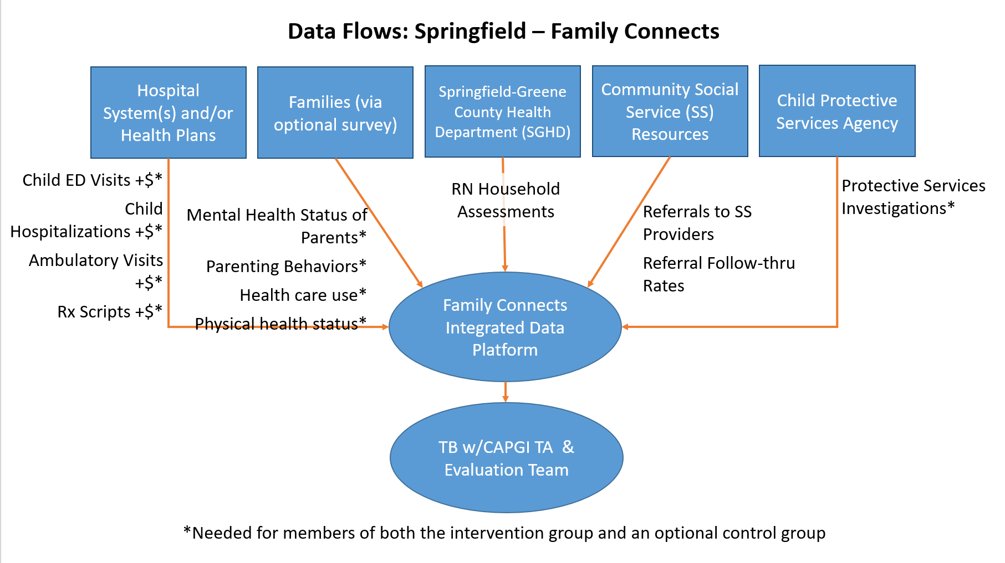

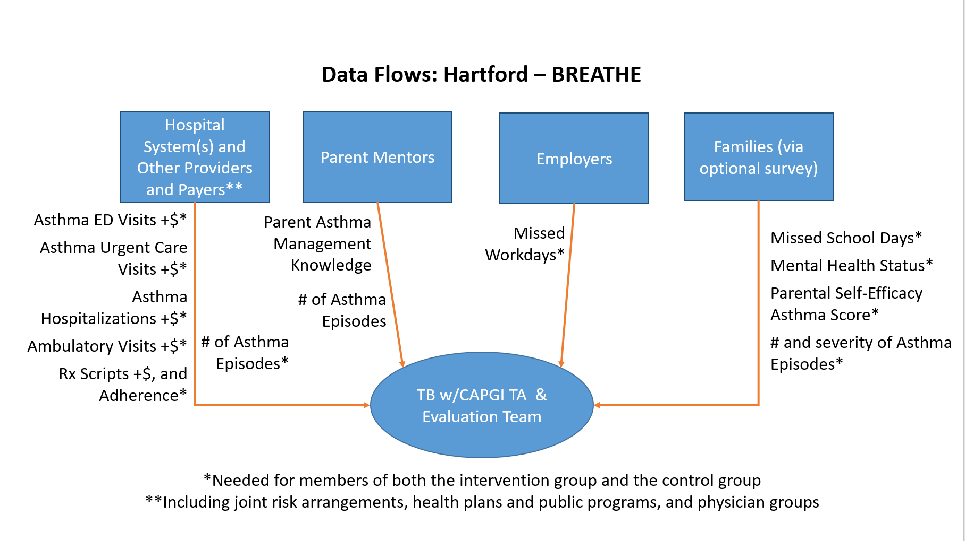
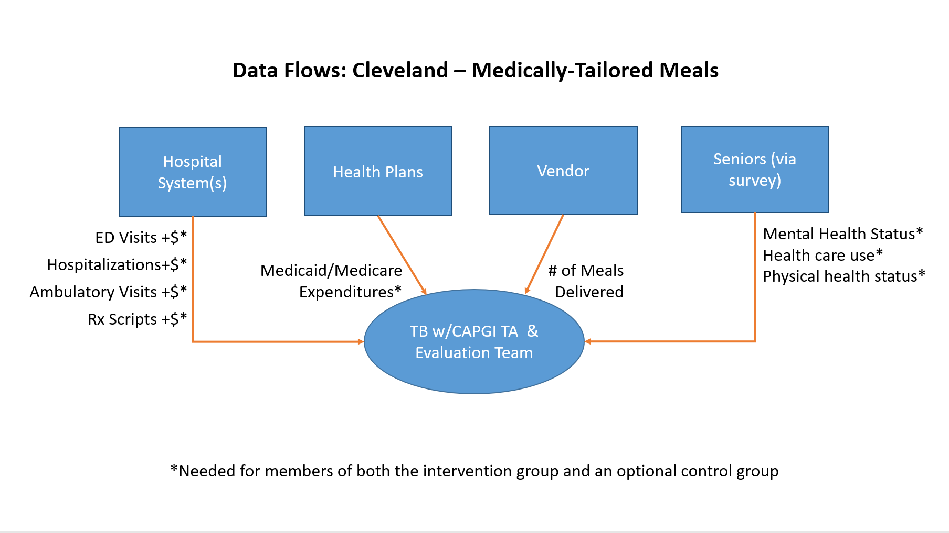

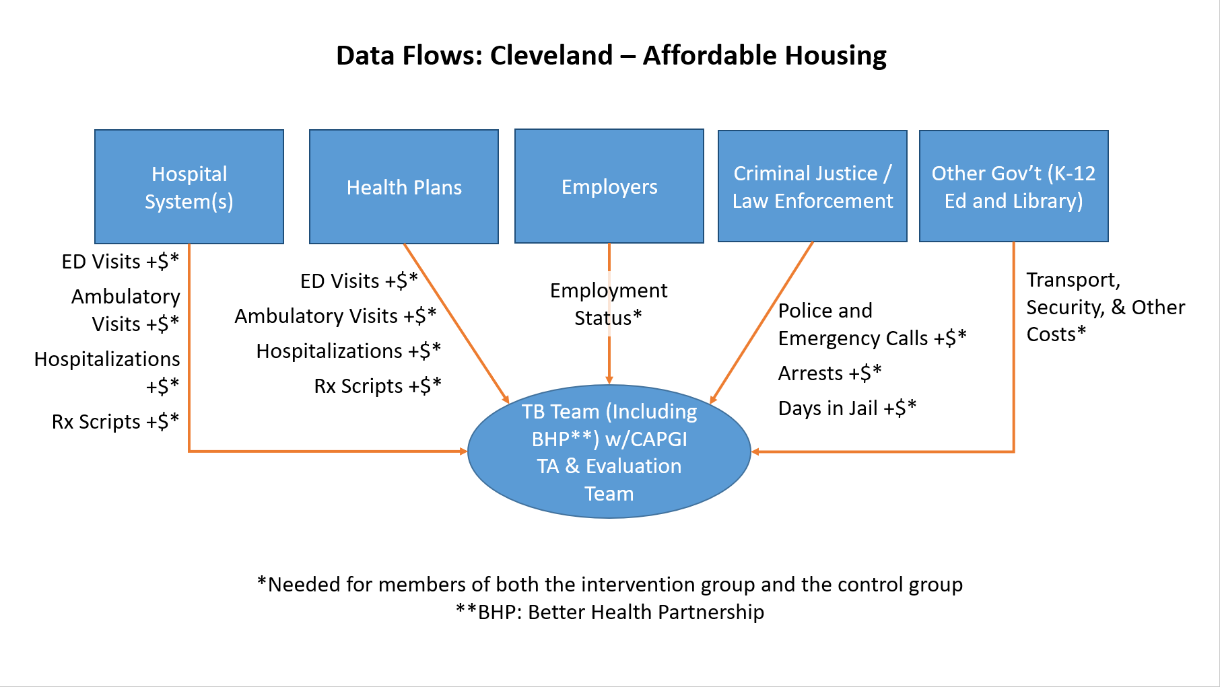

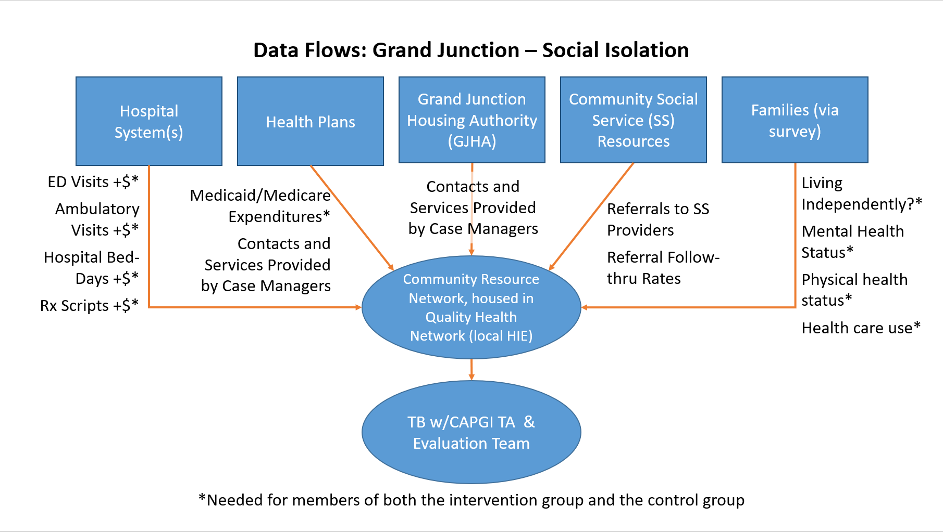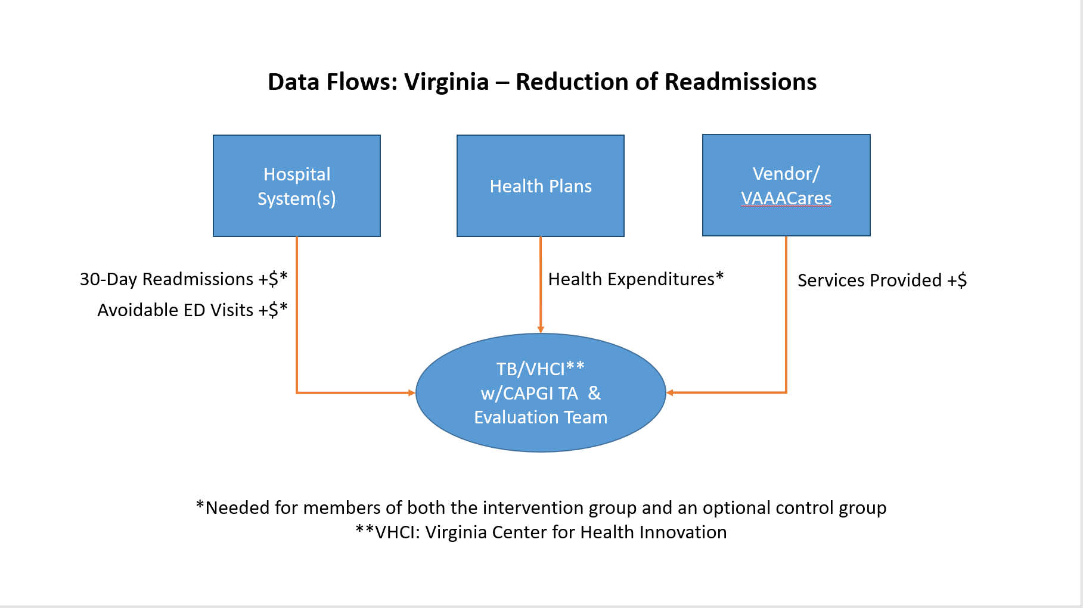

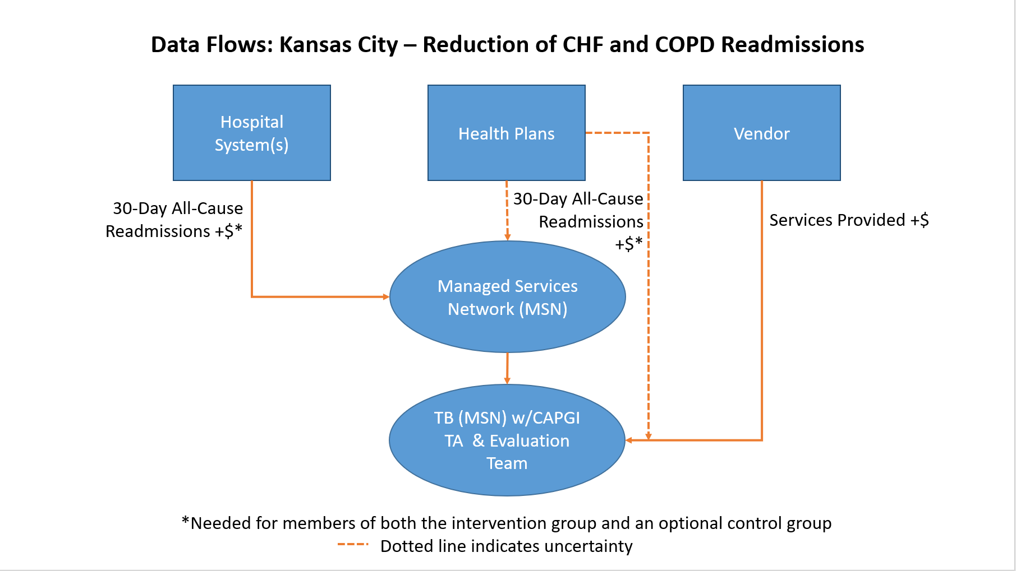

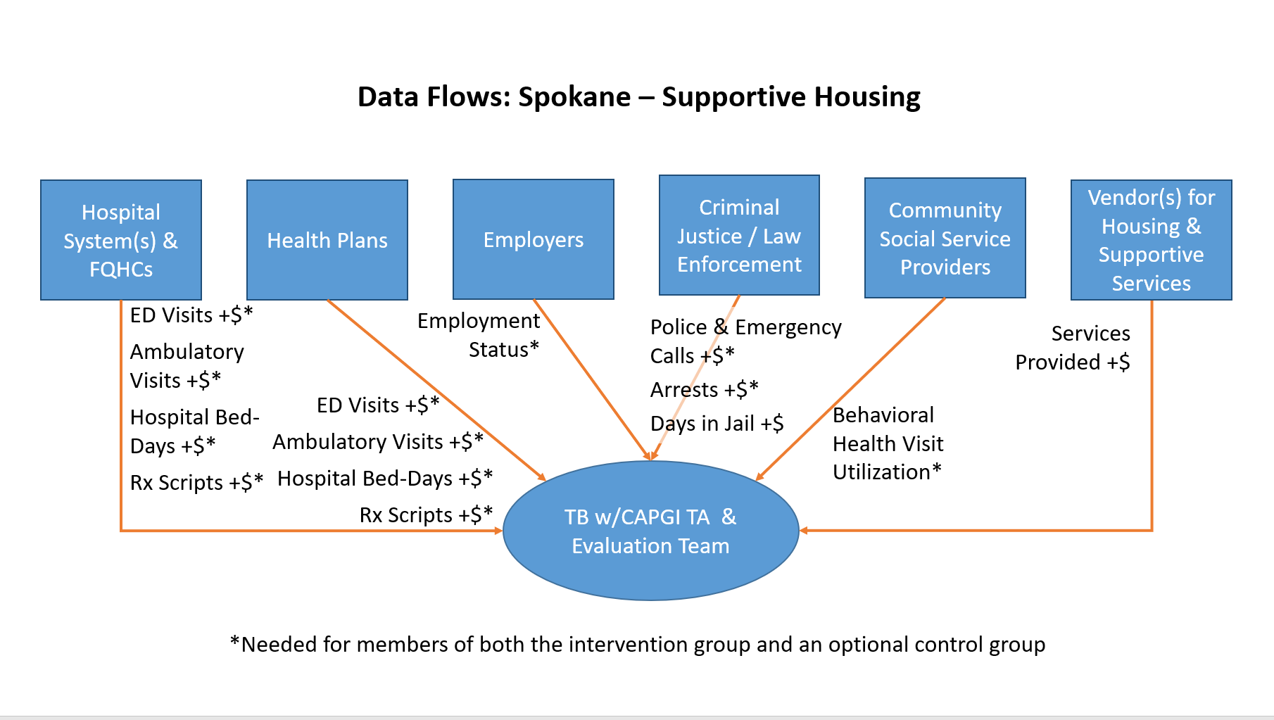
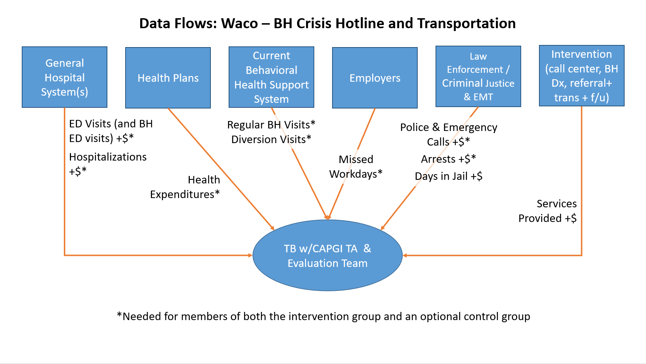

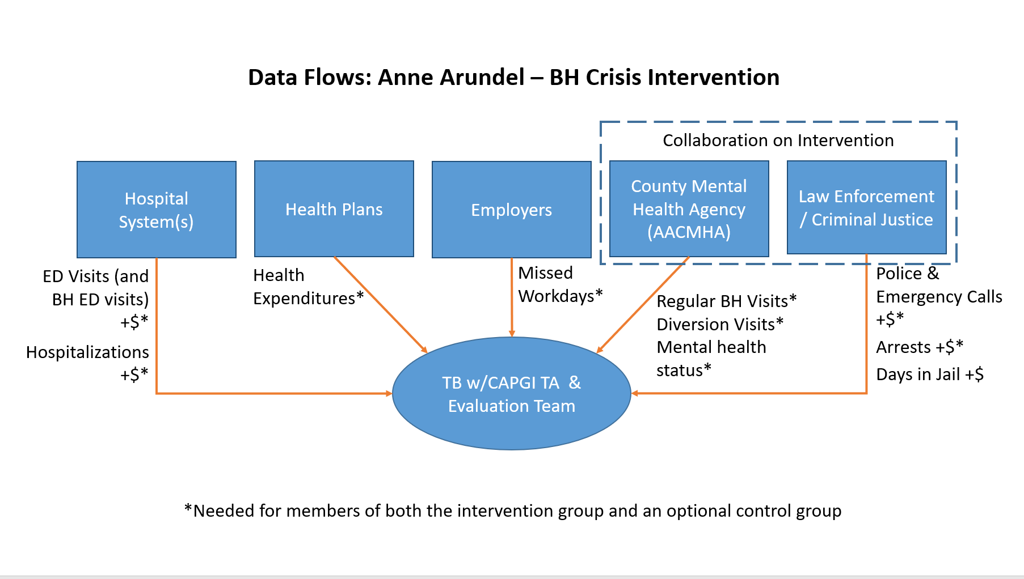
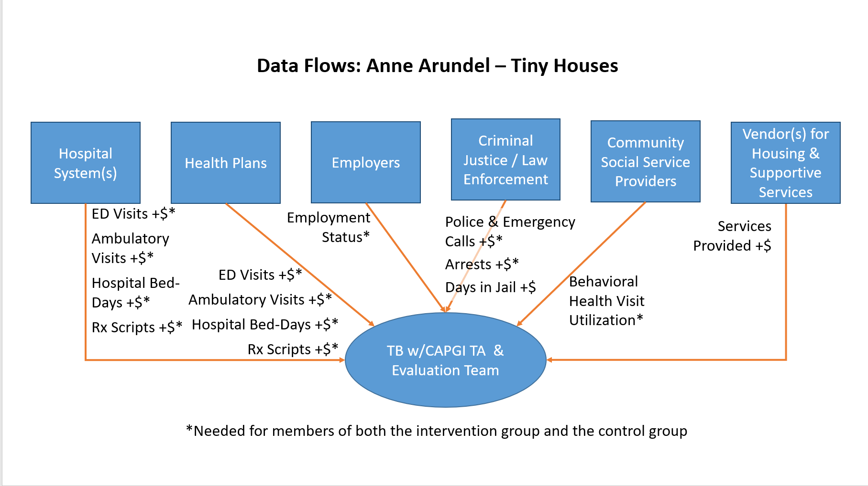
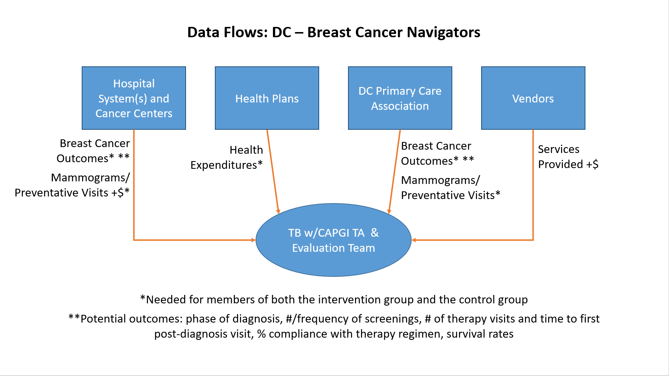

Appendix 6: Bibliography of SDOH evaluation literature relevant to interventions in CAPGI sites
Appendix 6 Table of Contents
Housing 43
Home Triggers of Asthma 45
Behavioral Health 51
Crisis Response System with Hotline and Response Team 53
Survey of Crisis Response Options 53
Street Triage and Mobile Crisis Teams 54
Police-Based Crisis Intervention Team (CIT) model 55
NYC EPASU 56
Seattle LEAD 56
Medically Tailored Meals 57
Isolation 59
Care Coordination 62
Systematic Reviews 70

Housing
Housing for Homeless
Upshot:
A number of strategies can help address homelessness, some more cost-effective than others, and some such as tiny houses requiring multiple collaborations for funding as well as zoning issues.
Basu, A., Kee, R., Buchanan, D., Sadowski, L. (2012). Comparative cost analysis of housing and case management program for chronically ill homeless adults compared to usual care. Health Services Research, 47(1), 523 – 543. Doi: 10.1111/j.1475-6773.2011.01350.x. Retrieved from https://www.ncbi.nlm.nih.gov/pmc/articles/PMC3393008/pdf/hesr0047-0523.pdf.
Three components: Interim housing at a respite center after hospital discharge; stable housing after recovery from hospitalization; and case management based in study hospital, respite and housing sites. Participants followed for 18 months. Intervention group generated an average savings of $6,307 per person; Chronically homeless generated an average savings of $9,809 - but probably cost neutral when considering cost to implement.
Larimer, M., Malone, D., Garner, M., Atkins, D., Burlingham, B., Lonczak, H., Tanzer, K., Ginzler, J., Clifasefi, S., Hobson, W., & Marlatt, A. (2009). Health care and public service use and costs before and after provision of housing for chronically homeless persons with severe alcohol problems. JAMA, 301(13), 1349-1357. Doi: 10.1001/jama.2009.414. Retrieved from https://jamanetwork.com/journals/jama/fullarticle/183666
"Housing First" intervention for chronically homeless with severe alcohol problems and high health care use and costs (including costs of jail bookings, days incarcerated, shelter and sobering center use, hospital based medical services, publicly funded alcohol and drugs detoxification and treatment, emergency medical services, and Medicaid-funded services). Individuals were placed in supportive housing with on-site case managers that engage residents on substance use. Intervention group had reduced total costs on average by $42,964 per person per year. On average (after implementation costs) savings of $29,564 per person per year.

American Hospital Association. (2017). Housing and the role of hospitals. Retrieved from https://www.aha.org/system/files/hpoe/Reports-HPOE/2017/housing-role-of-hospitals.pdf.
Stable housing and supportive services to chronically homeless individuals, case workers were used to help move into transitional housing followed by long-term independent housing. Early results suggest 42% drop in participants health care costs, 35% reduction in ED visits, and an increase in patients accessing clinics for routine care.

Hunter, S., Harvey, M., Briscombe, B., & Cefalu, M. (2017). Evaluation of housing for health permanent supportive housing program. Rand Corporation. Retrieved from https://www.rand.org/pubs/research_reports/RR1694.html.

Housing for Health, division within the LA County Dept of Health Services, provided supportive housing to homeless patients with complex medical and behavioral issues. Health care utilization reduced by 80% for ED visits; 61% for inpatient stays; and 47% for outpatient visits. Costs were reduced by 76% for inpatient services; 66% for emergency services and 59% for crisis stability services.

Hawk, M., & Davis, D. (2012). The effects of a harm reduction housing program on the viral loads of homeless individuals living with HIV/AIDs. AIDS Care, 24(5), 577-582. Doi: 10. 1080/09540121. Retrieved from https://www.ncbi.nlm.nih.gov/pubmed/22103666.

Harm reduction housing model - the program implemented the use of 4-part time Resident Monitors to provide support services. Significant difference between un-detectable viral load measures at baseline and at follow-up. Cost effectiveness analysis was not completed; small sample size; cannot determine the specific impact of this program. This housing was already established for homeless people, this program targeted individuals that were least likely to be served in traditional housing models.
Chhabra, M., Spector, E., Demuynck, S., Wiest, D., Buckley, L., & Shea, J. (2020). Assessing the relationship between housing and health among medically complex, chronically homelss individuals experiencing frequent hospital use in the United States. Health and Social Care, 28, 91-99. Doi: 10.1111/hsc.12843. Retrieved from https://onlinelibrary.wiley.com/doi/full/10.1111/hsc.12843.
Housing First Model. Housing facilitates stability and security, improving management of health conditions for formerly homeless individuals with significant medical needs. • Case managers play a critical role in connecting Housing First clients to services and help mitigate feelings of isolation. • Housing facilitates re‐connection with friends and family, but clients in scattered‐site programs can experience stigmatization and a lack of social integration.

Brothers, S., Lin, J., Schonberg, J., Drew, C., & Auerswald, C. (2020). Food insecurity among formerly homeless youth in supportive housing: A social-ecological analysis of a structural intervention. Social Science & Medicine, 245. Doi: 10.1016/j.socscimed.2019.112724. Retrieved from https://www.sciencedirect.com/science/article/abs/pii/S0277953619307191
While housing removed some major sources of food insecurity, it actually added others. Youth not knowing about food resources, not knowing about kitchen us and food storage policies in the house, and limited cooking skills and equipment all impacted food insecurity.

Gusmano, M., Rodwin, V., & Weisz, D. (2018). Medicare beneficiaries living in housing with supportive services experienced lower hospital use than others. Health Affairs, 37(10). Doi: 10.1377/hlthaff.2018.0070. Retrieved from https://www.healthaffairs.org/doi/full/10.1377/hlthaff.2018.0070
Affordable housing with supportive social services (Medicaid-funded home services, SNAP, psychological assessments, counseling, advocacy, health education, wellness, and access to list of local service providers (including transportation, physicians and pharmacy). Total hospital discharge rate was 32% lower for intervention group; Rate of hospital discharge for ambulatory care sensitive conditions was 30% lower for intervention group; and Mean length of stay was 1 day shorter for intervention group.
Jackson, A., Callea, B., Stampar, N., Sanders, A., De Los Rios, A., & Pierce, J. (2020). Exploring tiny homes as an affordable housing strategy to ameliorate homelessness: A case study of the Dwellings in Tallahassee, FL. International Journal of Environmental Research and Public Health, 17, 661. Doi: 10.3390/ijerph17020661. Retrieved from https://www.mdpi.com/1660-4601/17/2/661.
A tiny home community for homeless in Tallahassee, FL. The development of this community (130 tiny homes and community center) and the issues that arose are chronicled in this manuscript. There are limitations to the level of affordability in this community; there are limitations by the local, state and federal policies that support non-profit affordable housing, which creates barriers. Funding from both private and public entities will make this financially sustainable in the long-term.

Tomita, A., & Herman, D. (2012). The impact of critical time intervention in reducing psychiatric rehospitalization after hospital discharge. Psychiatr Serv., 63(9), 935-937. Doi: 10.1176/appi.ps.201100468. Retrieved from https://www.ncbi.nlm.nih.gov/pubmed/22810163.

Critical time intervention (CTI), time-limited case management model focused on building and strengthening community support systems during critical transition periods. Reduction in psychiatric re-hospitalizations.

Home Triggers of Asthma
Multi-component, multi-trigger home visits and parent counseling for asthma
Upshot: Targeting higher-severity cases yields a surer cost-savings, but programs are generally cost-effective.
Lantz, P. M., Miller, G., Rhyan, C. N., Rosenbaum, S., Ku, L., & Lovan, S. (2018). “Pay for Success” Financing and Home-Based Multicomponent Childhood Asthma Interventions: Modeling Results from the Detroit Medicaid Population: Pay for Success Financing and Childhood Asthma. The Milbank Quarterly, 96(2), 272–299. https://doi.org/10.1111/1468-0009.12325
This paper introduces an estimation of cost savings in medical services rendered by an intervention in an urban Medicaid population, over the course of 7 years. The savings are apportioned according to a social impact bond model, where private investment funds the intervention and reaps cost-savings up to 110% of the intervention cost; thereafter, public systems reap any savings. Expected program outcomes were modeled upon data about Detroit’s Medicaid population of children with asthma. Reflecting the literature, targeting the intervention to more acute cases results in greater savings. Indeed, when all 7,619 asthmatic children in Detroit Medicaid were targeted, the program costs were not returned in averted medical savings over the 7-year period. Alternatively, targeting a high-severity asthma population with recent hospitalization would reap more savings ($4.1 million) relative to a smaller cost ($499,000 to intervene for 510 children, and thereafter $101,000 yearly). Under a shorter term like 3 years, this would still yield significant benefits: $865,000 in public savings, on top of 110% of the program cost returned to investors. The program modeled is unique because it uses a social impact bond financial structure. It also positions Medicaid managed care organizations (MCOs) as implementers, and MCOs would capture an uncalculated amount of the intervention effects in year one. Savings for the private investor and the public systems rely on quickly and accurately recalculating fixed payments to MCOs based on expected intervention effects. Other models were analyzed, briefly.
Nurmagambetov, T. A., Barnett, S. B. L., Jacob, V., Chattopadhyay, S. K., Hopkins, D. P., Crocker, D. D., Dumitru, G. G., & Kinyota, S. (2011). Economic Value of Home-Based, Multi-Trigger, Multicomponent Interventions with an Environmental Focus for Reducing Asthma Morbidity. American Journal of Preventive Medicine, 41(2), S33–S47. https://doi.org/10.1016/j.amepre.2011.05.011
A 2011 special issue of the American Journal of Preventive Medicine was devoted to “home-based environmental interventions” and included two systematic reviews relevant to Hartford’s proposal. One reviewed the program outcomes and the other investigated economic valuations of the programs. These reviews match the Hartford proposal neatly: they consider only “multi-trigger, multicomponent interventions” that include both counseling (often peer-based) and some environmental modification. Counseling was often conducted both during home visits and in groups of parents. In the economic-value review, 11 studies were in the US and 9 of these targeted youth and adolescents. Program cost ranged from $200 to $14900, largely reflecting the extent of environmental remediations paid for. Because of the range of program costs, ICERs ($ per symptom free day) and benefit-cost ratios ($ saved per $ spent) were quite variable across 6 studies reporting health and health-cost outcomes. The only other outcome that was monetized was productivity (of parents). A key determinant of home visit costs per visit was the profession of the visitor employed, and a key determinant of cost savings was how severe asthma cases had to be to generate eligibility. Higher severity requirements and lower-cost home modifications tended to yield cost-savings.
Home visit programs with hazard reduction can be cost saving even in a 1- or 2-year time frame, but not assuredly. Long-term cost-savings effects are understudied. One care delivery intervention, targeting higher severity asthma patients with frequent respiratory therapist visits and family education and hazard removal yielded net savings. Consistently, home-based interventions to address asthma triggers yielded reductions in health care utilization, in the literature up to 2008. By reducing hospital, ED, and office visits alike, the interventions can consistently yield medical savings. But whether program costs outweigh savings is inconsistently answered: 2 moderate and 1 light interventions yielded net program savings but 2 moderate and 1 light intervention yielded less savings than program costs. By addressing symptoms, they improve productivity and perhaps also quality of life and pulmonary function. It is unclear whether there are long-term benefits that could yield more unobserved avoided costs.
Ebell, M. H. (2019). A Multicomponent, Multi-Trigger Intervention to Enhance Asthma Control in High-Risk African American Children. Preventing Chronic Disease, 16. https://doi.org/10.5888/pcd16.180387
This intervention involved 2 home visits by an environmental health worker, group self-management training (the “Wee Breathers” curriculum), and continuous case management. The group targeted was children who were dually enrolled in Medicaid and in Georgia’s case management program for children; they were ages 0-17, and their asthma was not well controlled or worse. (i.e., their asthma caused 1+ hospitalizations or 2+ emergency department visits in a half-year, weekly daytime and monthly nighttime symptoms, and a limitation of routine activity.) The sample was small (23), the follow-up period was 12 months, and the design employed pre-post comparison without a control. Trigger mitigation suggestions made during visits were not necessarily implemented (about half were), although Georgia’s case management program could pay for some recommended equipment, limiting financial barriers to treatment compliance. Asthma control, symptoms, and activity limitations were meaningfully improved by the intervention, as were outcomes like school absence and ED visits. Outcomes were based on self-report, limiting study strength.
Fernandes, J. C., Biskupiak, W. W., Brokaw, S. M., Carpenedo, D., Loveland, K. M., Tysk, S., & Vogl, S. (2019). Outcomes of the Montana Asthma Home Visiting Program: A home-based asthma education program. Journal of Asthma, 56(1), 104–110. https://doi.org/10.1080/02770903.2018.1426766
This intervention involved 4-6 home visits by a nurse during 12 months who delivered self-management training. The group targeted was children ages 0-17 with uncontrolled asthma (determined by a recent asthma ED visit or a low asthma control test score) in rural areas. The sample was large (338 children), the measured period was concurrent to intervention (12 months), and the study compared completion against partial completion of the intervention. Trigger mitigation equipment was provided during the visits if not implemented by the family in the first several months. The results therefore show the incremental benefits of completion, which were generally reduced symptoms, activity limitations, use of unscheduled care or pharmacotherapy, and school or work absence. Participants’ number of unscheduled or ED care visits in the prior half-year declined by 1.7 after 12 months, when the intervention completed. Outcomes were based on a mix of self-report, validated instruments, and nurse observation. A further concern is the lack of a comparison group: those who remain in the program at 12 months may be those seeing the most benefit.

Swann, J. L., Griffin, P. M., Keskinocak, P., Bieder, I., Yildirim, F. M., Nurmagambetov, T., Hsu, J., Seeff, L., & Singleton, C.-M. (2019). Return on investment of self-management education and home visits for children with asthma. Journal of Asthma, 1–10. https://doi.org/10.1080/02770903.2019.1690660
This paper introduces a simulation of likely program costs and health care costs incurred if a state’s Medicaid-enrolled children with asthma were treated with self-management education outside of the home, or by home visits, or by neither. The authors cite 14 studies to estimate program costs and effects, 4 of which are systematic reviews. The simulation has a 3-year horizon, and takes a person as its unit of analysis. The simulation is then demonstrated using an extract of New York’s Medicaid administrative data from 2010-2011. In their simulations, one eligibility criterion – the severity of asthma cases is measured by recent acute-care visits – is relevant to the consistency of a cost-savings: targeting more severe cases increases the likelihood of net savings but reduces the number of treated persons, assuming a program could reach all eligible. The authors conclude that their simulation tool and demonstration underscore the program can be unilaterally executed by a Medicaid agency, and the agency on its own would probably yield net savings in just several years. The Python and Excel are reportedly available for planners, but not clearly downloadable in the article’s webpage or the authors’ webpages.
Sullivan, S. D., Weiss, K. B., Lynn, H., Mitchell, H., Kattan, M., Gergen, P. J., & Evans, R. (2002). The cost-effectiveness of an inner-city asthma intervention for children. Journal of Allergy and Clinical Immunology, 110(4), 576–581. https://doi.org/10.1067/mai.2002.128009
Home visits for asthma-management counseling, including environmental-trigger control training, investigating asthma triggers in the home, providing minor equipment to limit triggers (equipment like bed covers), and cockroach extermination if children tested as allergic to them. 8 visits and two group asthma counseling sessions for parents/guardians were rendered to families of 1033 children with severe recent asthma care use. The intervention occurred in 8 urban neighborhoods in 7 cities and targeted 5- to 11-year-old children with asthma. The program had unclear net effects on medical care, where counseling may induce care use, medication adherence, etc. that increase medical spending. The program cost $337 per child for 2 years. It had no significant difference in care use overall, and samples' intervention groups saw higher asthma-related care costs. Overall, the incremental cost-effectiveness ratio (ICER) was $9.20/symptom-free day. However, the care costs were lower for the intervention group among high-severity asthmatic children (not statistically significant). “It is only about 20% likely that implementation of the program, as carried out by the NCICAS investigators, would result in cost savings." This randomized control trial offered a large N and decent (2-year) follow up. Only medical visits/admissions were considered for the savings estimate, missing the medication and potential productivity effect of fewer missed school days, etc. Home visits for asthma can be coupled with system navigation services that connect participants with public programs and insurance options, reduce cultural barriers to ambulatory care, and improve self-management of asthma. Social workers can serve this role. Cost-Savings: Unlikely - 20% chance that a replicate program would yield net savings. While the program's costs were relatively low for the type of program, its savings were low (and not significantly nonzero).
Kattan, M., Stearns, S. C., Crain, E. F., Stout, J. W., Gergen, P. J., Evans, R., Visness, C. M., Gruchalla, R. S., Morgan, W. J., O’Connor, G. T., Mastin, J. P., & Mitchell, H. E. (2005). Cost-effectiveness of a home-based environmental intervention for inner-city children with asthma. Journal of Allergy and Clinical Immunology, 116(5), 1058–1063. https://doi.org/10.1016/j.jaci.2005.07.032
Home visits by environmental counselors, including moderate remediation of asthma triggers for disadvantaged urban children. Families of 937 low-SES children in urban neighborhoods in 7 cities aged 6-11 with moderate-to-severe asthma. (469 in intervention.) Increased symptom free days per year by 38 days. Program cost an average $1720 per family. $555 of direct medical costs averted. B-C ratio: 0.32. ICER: $31/SFD. 5-7 visits over 12 months. 12 months, after intervention. Productivity reported but not monetized. RCT with non-intervention control group matched retrospectively. Costs were decomposed in detail. Note in comparison with Sullivan et al. that the two studies with the largest samples had different structures and costs but yielded similar B-C ratios (0.32 for both) that indicate no net savings. This deflates the motivation that other studies but suggests that net savings may be reliably attained with a different program structure, esp. targeting worse cases/cases frequenting acute care. Cost-effectiveness: In this case, with high program costs, the cost-effectiveness was relatively low (especially if we accept that 1800 SFD = 1 QALY): this cost $31/SFD.
Oatman, L. (2007). Reducing Environmental Triggers of Asthma in Homes of Minnesota Children. Minnesota Department of Health. http://www.asthmaawards.info/system/files/ResourseUploads/RETA%20report%20excerpts%20Sept%202007.doc
Moderate environmental remediation coupled with home visits -- 3 visits by respiratory therapist -- including environmental- plus self-management training. Families of 64 low-SES children ages 0-18 in the Twin Cities (MN). A second trial of delivering respiratory therapists' care in the home for more severe asthma cases yielded net savings, but only in a small population (n=64 here and n=18 above) and without a control.
Jowers, J. R., Schwartz, A. L., Tinkelman, D. G., Reed, K. E., Corsello, P. R., Mazzei, A. A., Bender, D. R., & Lochhead, R. A. (2000). Disease Management Program Improves Asthma Outcomes. The American Journal of Managed Care, 6(5), 8.
Modest environmental remediation coupled with home visits -- 2 visits by a nurse -- that was widely targeted across age and asthma severity, coupled with self-management training. 317 households of all ages, socioeconomics, and any asthma severity in Western Pennsylvania. Medical costs averted and productivity gained. The study did not report symptom-free days. Average cost of $377 per participant. But program yielded $2,181 of medical cost averted, $772 of productivity loss saved. Benefit-to-cost ratio: 7.8. (i.e., the net savings by taking the gain in productivity and the medical costs averted, over program costs.) Observed participants at 6th and 12th months. Pre-post evaluation. Coupling modest environmental improvements with a self-management intervention can yield cost-savings in medical costs averted when targeting a wide group of asthmatic persons, but in a trial without a control. The benefits extend to non-urban settings. A nurse can perform this work.
Shelledy, D. C., McCormick, S. R., LeGrand, T. S., Cardenas, J., & Peters, J. I. (2005). The effect of a pediatric asthma management program provided by respiratory therapists on patient outcomes and cost. Heart & Lung, 34(6), 423–428. https://doi.org/10.1016/j.hrtlng.2005.05.004
For asthmatic children, 6 home visits with environmental remediation, or 6 visits that identified asthma triggers with only referral to asthma management resources. All remediation was intended to be low-cost. Home equipment provided with training, offering pest control, cleaning supplies, and linens. The intervention sample was families of 281 low-socioeconomic-status ("low-SES") children ages 2-16 in Philadelphia, almost all African-American, with at least one hospitalization or 2 ED visits for asthma in prior year. Rx use declined selectively: daily Albuterol use dropped almost in half for both groups. Daily controller medicine use remained high for all. Acute care use declined: Reduced hospitalizations per child 47% and 43% in the major and minor intervention groups, respectively versus their baseline month. Hospitalization reduced in both groups versus the control (p=0.02, 0.05). Reduced ER similarly by about half in both groups, versus control with higher ER use after 12 months. Those given home equipment and direct education had no better inpatient reduction versus just home visits and referral to group training. Intermediate outputs: home remediation had meaningfully better and sustained effects of removed triggers (rodents, carpet, cockroaches) and of protective actions (use of linens, e.g.). The program cost an average $675 per family. As a subset, the environmental remediation averaged $120 per family. 12 months were observed. Design: two-arm randomized trial with a nonintervention control group matched retrospectively by age, gender, and ethnicity. Outcomes: Self reports of symptomatic days, self-reported Rx use, and health-record-based inpatient care measure. Only inpatient care measured as an outcome – not costs.
Krieger, J. W., Takaro, T. K., Song, L., & Weaver, M. (2005). The Seattle-King County Healthy Homes Project: A Randomized, Controlled Trial of a Community Health Worker Intervention to Decrease Exposure to Indoor Asthma Triggers. American Journal of Public Health, 95(4), 652–659. https://doi.org/10.2105/AJPH.2004.042994
Seattle-King County Healthy Homes Project: Home visits by community health workers, including moderate remediation of asthma triggers for disadvantaged urban children. A second intervention (the control) was conducted with just one visit, offering allergen-reducing bedding and light environmental-risk education. Families of 274 low-SES children in Seattle area aged 4-12 with persistent, mild-to-severe asthma. Increased symptom free days per year by 21 days. (Note this is the incremental gain for multiple visits, the intense intervention group, versus a single-visit control group.) Program cost an average $1316 per family. (Unclear how costly was the control intervention.) $124-147 of direct medical costs averted. Benefit-cost ratio: 0.09-0.11. ICER: $56-$57/SFD. (Note this is the incremental cost-benefit for multiple visits, the intense intervention group.) 5-9 visits. 6 months observed. RCT with a low-treatment-intensity control group. Studied difference made by major intervention (5-9 visits) versus one visit with bedding encasement plus some education. This study involved trained laypersons to act as home visitors.

Bryant-Stephens, T., & Li, Y. (2008). Outcomes of a Home-Based Environmental Remediation for Urban Children with Asthma. Journal of the National Medical Association, 100(3), 306–316. https://doi.org/10.1016/S0027-9684(15)31243-8
Families of 281 low-socioeconomic-status ("low-SES") children ages 2-16 in Philadelphia, almost all African-American, with at least one hospitalization or 2 ED visits for asthma in prior year. (Intervention) Rx use: daily Albuterol use dropped almost in half for both groups. Daily controller medicine use remained high for all. Acute care use: Reduced hospitalizations per child 47% and 43% in the major and minor intervention groups, respectively versus their baseline month. Hospitalization reduced in both groups versus the control (p=0.02, 0.05). Reduced ER similarly by about half in both groups, versus control with higher ER use after 12 months. Those given home equipment and direct education had no better inpatient reduction versus just home visits and referral to group training. Intermediate outputs: home remediation had meaningfully better and sustained effects of removed triggers (rodents, carpet, cockroaches) and of protective actions (use of linens, e.g.). Average $675 per family. Environmental remediation averaged $120 per family. 6 visits over 12 months. 12 months observed. Two-arm randomized trial with a nonintervention control group matched retrospectively by age, gender, and ethnicity. Self-reports of symptomatic days, self-reports of Rx use, and health-record-based inpatient care measure. Only inpatient care measured as an outcome – not costs.

Behavioral Health
Financial Vouchers for Services and Supports for Behavioral Health Population

Croft, B., Battis, K., Isvan, N., & Mahoney, K. J. (2020). Service Utilization Before and After Self-Direction: A Quasi-experimental Difference-in-Differences Analysis of Utah’s Mental Health Access to Recovery Program. Administration and Policy in Mental Health and Mental Health Services Research, 47(1), 36–46. https://doi.org/10.1007/s10488-019-00969-4
Self-directed cash benefits were granted to 94 participants in Utah – vouchers for up to $2000, of which the average amount used per participant was $904. The most common services used were transportation, dentistry, housing, and wellness or fitness. Administrative data captured all behavioral health services paid for by Medicaid or the state and rendered to the intervention group or to a matched comparison group. The intervention group used significantly more behavioral health services, both rehabilitation and outpatient visits (63 hours and 22 hours more, respectively). Matching variables included demographic, household, Medicaid eligibility, serious mental illness status, mental health diagnoses and treatments, and days and hours of behavioral health and emergency service usage. A regression model was specified for each of four outcome variables: rehabilitation, outpatient, and residential treatment hours used, as well as emergency room use. The latter two variables were not influenced by program participation. While service use increased, the authors note that other recent research has found similar models of self-directed benefits “improved housing and employment outcomes [and] improvements in recovery and other psychosocial outcomes.” (See two entries below, Croft et al., 2018, and Cook et al., 2019.) The methods rely powerfully on merged public behavioral health services data, based on administrative records, to estimate the program effects on BH service utilization. These are generally available for a large group of other behavioral health users who can be matched with program participants as a quasi-experimental control.
Croft, B., Battis, K., Ostrow, L., & Salzer, M. S. (2019). Service costs and mental health self-direction: Findings from consumer recovery investment fund self-directed care. Psychiatric Rehabilitation Journal, 42(4), 401–406. https://doi.org/10.1037/prj0000374
This study used Medicaid administrative data only in a managed care setting in Pennsylvania and found some reduced mental health care costs after receipt of self-directed benefits. Specifically, monthly clinical outpatient costs for mental health dropped $42 after the program (p <0.001 for a non-zero change); no other mental health service category – crisis and inpatient care, community support/coordination, outpatient and community-based services – saw reduced monthly costs. The monthly mean cost of the program was $182. Net costs did not change statistically significantly, but the sample saw an increased $84 monthly net cost post-intervention, factoring in cash benefit versus Medicaid costs. There was no control group; the design was an unadjusted pre-post.
Cook, J. A., Shore, S., Burke-Miller, J. K., Jonikas, J. A., Hamilton, M., Ruckdeschel, B., Norris, W., Markowitz, A. F., Ferrara, M., & Bhaumik, D. (2019). Mental Health Self-Directed Care Financing: Efficacy in Improving Outcomes and Controlling Costs for Adults With Serious Mental Illness. Psychiatric Services, 70(3), 191–201. https://doi.org/10.1176/appi.ps.201800337
With no significant change in total costs, self-directed cash benefits in Texas rendered improved care for behavioral health clients. This randomized control trial examined self-perceived recovery, psychosocial status, psychiatric symptoms, and behavioral rehabilitation between self-directed care (treatment, N = 114) and services-as-usual (control) groups. The control group was an intent-to-treat population. Over 2 years per-capita costs were not meaningfully different between the two groups, but the self-directed care group had improvements in the psychometric outcomes and self-esteem and work/education status relative to the control. The psychometric outcome data were collected by research staff through interviews, but utilization and cost data were accessed from a state health care claims data repository and the self-directed program administrative records.
Croft, B., İsvan, N., Parish, S. L., & Mahoney, K. J. (2018). Housing and Employment Outcomes for Mental Health Self-Direction Participants. Psychiatric Services, 69(7), 819–825. https://doi.org/10.1176/appi.ps.201700057
The methods of this study on FloridaSDC largely match Croft et al., 2020, with the intervention group (n=271) matched to a comparison on demographic and diagnostic variables. The SDC recipients had about twice the odds of accessing and keeping housing, and 1.7-fold odds of working for pay in the past month.
Spaulding-Givens, J. C., & Lacasse, J. R. (2015). Self-directed care: Participants’ service utilization and outcomes. Psychiatric Rehabilitation Journal, 38(1), 74–80. https://doi.org/10.1037/prj0000103
For patients with severe and persistent mental illness, a self-directed care cash benefit was granted after development of a budgeted-out recovery plan by the patient and a recovery coach. There was no comparison group, but for the 136 sampled participants, employment was uncommon, and the cash was put toward living expenses. 80% of the expenditures went to nontraditional services, especially transportation, dentistry, housing, utilities, and food. “FloridaSDC participants choose to spend a substantial amount of their allotted budgets to meet their basic needs, including transportation, housing, and utilities.” The sampled participants may be a biased subset because they were the participants who consented to review of their financial records. The Functional Assessment Rating Scale (FARS) was employed at outset and 6-month follow-up, and severe mental health problems decreased over time, with the most precipitous decline in depression and issues with work.

Crisis Response System with Hotline and Response Team
Upshot:
A response team can be formed or modeled after procedurally successful programs to intervene in behavioral health crises in (1) community mental health worker contexts, (2) law enforcement contacts, and (3) booking contexts. However, the outcomes for health use and justice use are sparsely or inadequately evaluated as of 2020. In the Texas setting, regional emergency networks have been integrated with these efforts. Challenges with methods to capture the effect of the program on system use and health outcomes are numerous and well-reported. Some studies have overcome these challenges by randomizing according to officer shifts, as well as use of good administrative data streams.

Survey of Crisis Response Options
Watson, A. C., Compton, M. T., & Pope, L. G. (2019). Crisis Response Services for People with Mental Illnesses or Intellectual and Developmental Disabilities: Vera Institute of Justice. https://www.vera.org/downloads/publications/crisis-response-services-for-people-with-mental-illnesses-or-intellectual-and-developmental-disabilities.pdf
This 2019 review discusses the evidence bases available about first-response strategies for persons with mental illness or intellectual/developmental disabilities. It underscores how intertwined law enforcement tend to be with models of community behavioral health crisis response. The role of law enforcement versus health professionals in each program is a crucial distinction addressed. Case management targets frequent utilizers by staffing a behavioral health worker with police to address their needs longitudinally. Co-responder teams address crises with a similar pairing of police with a BH professional. Crisis Intervention Teams are a police-led intervention to deescalate and handoff mental health crises. Ambulance or EMS teams may also be involved. Mobile crisis teams are grouped behavioral health professionals who respond to a scene of a crisis in the community, e.g a social worker, nurse, and peer specialist, and these offer an alternative to hospitalization by de-escalation at the scene of the crisis. Law enforcement can receive training, receive notifications of registered mental health cases for which they can call a service provider, or call in a specialist or advocate. These form a continuum of programs that can complement one another. Cost-effectiveness evidence was sparsely identified, mostly for CIT. Over a 12-month period in Memphis, each CIT diversion was associated with an increased cost of $6,576 (avoided jail costs were lesser than added hospitalization). A decade later, a Louisville, KY, implementation of CIT resulted in net savings of $1,024,897. The authors suggest that the context of program design determines the net system costs, but do not describe the design or scale of the Louisville implementation. A Georgia response model reduced system costs – and improved care and reduced arrests – when eligible 911 calls were referred to a state crisis hotline that would deescalate the crisis or else dispatch a team consisting of a counselor, social worker, and psychiatry trainee.

Street Triage and Mobile Crisis Teams

Puntis, S., Perfect, D., Kirubarajan, A., Bolton, S., Davies, F., Hayes, A., Harriss, E., & Molodynski, A. (2018). A systematic review of co-responder models of police mental health ‘street’ triage. BMC Psychiatry, 18(1), 256. https://doi.org/10.1186/s12888-018-1836-2
Mental health triage/mobile crisis teams can be conducted either by staffing a mobile unit for dispatch to mental health crisis cases, or by staffing mental health nurses in police cars or ambulances to be dispatched. All studies reporting arrest outcomes found that arrest was reduced, suggesting successful de-escalation or diversion to treatment. Extant studies as of 2018 had disagreement about the programs’ effects on psychiatric hospitalizations. One study disaggregated involuntary from voluntary hospitalizations and found that its observed net increase in hospital use was due to higher voluntary use, despite lower involuntary use. From a cost-savings perspective, this leaves the cost effect unpredictable or ambivalent. Of three studies on net cost effectiveness, two suggested the triage lowered average cost per response; the other found a trivial change in cost. Costs shifted from justice system to health system, so cost-effectiveness could hinge on the size and direction of change in hospitalization use, and in cases where use increased, then it would hinge on the outcomes of the health care use. The current evidence remains weak, and much of the literature emerged in the three years leading up to 2018.
Mobile Crisis Outreach Teams are standardized in Texas, and they are well integrated with law enforcement, the health system, and social services in Bexar County in particular: see Table 18: Adult Crisis Services in Bexar County, in https://www.texasstateofmind.org/wp-content/uploads/2016/11/2016-Bexar-County-Mental-Health-Report_FNL.pdf on page 25. The same report offers breakdowns of the 974 crisis response program/hotline users in 2015 according to age and use of other public-service systems. Notably, Bexar’s integrated approach has been both collaborative and orchestrated, notably by the Southwest Texas Crisis Collaborative with the Southwest Texas Regional Advisory Council.
Callender, M., Knight, L. J., Moloney, D., & Lugli, V. (2019). Mental health street triage: Comparing experiences of delivery across three sites. Journal of Psychiatric and Mental Health Nursing, 2020(00). https://doi.org/10.1111/jpm.12584
This qualitative study of police and health teams implementing street triage in 3 sites in the UK found that police focused on the program’s potential to reduce enforcement costs, while the health team saw it as a mode of care delivery. These dual focuses could be recognized early, by setting explicit goals in both domains to achieve mutually appreciated program effects.

Police-Based Crisis Intervention Team (CIT) model
Rogers, M. S., McNiel, D. E., & Binder, R. L. (2019). Effectiveness of Police Crisis Intervention Training Programs. Journal of the American Academy of Psychiatry and the Law Online. https://doi.org/10.29158/JAAPL.003863-19
Watson, A. C., & Compton, M. T. (2019). What Research on Crisis Intervention Teams Tells Us and What We Need to Ask. Journal of the American Academy of Psychiatry and the Law Online, 47(4), 422–426. https://doi.org/10.29158/JAAPL.003894-19
Compton, M. T., Bakeman, R., Broussard, B., Hankerson-Dyson, D., Husbands, L., Krishan, S., Stewart-Hutto, T., D’Orio, B. M., Oliva, J. R., Thompson, N. J., & Watson, A. C. (2014). The Police-Based Crisis Intervention Team (CIT) Model: II. Effects on Level of Force and Resolution, Referral, and Arrest. Psychiatric Services, 65(4), 523–529. https://doi.org/10.1176/appi.ps.201300108
In a 2019 review, the University of Memphis estimated that 2,700 or 40% of police departments in the United States employed the CIT model. The model appears to reduce police burden from responding to mental illness crises by standardizing, delegating, and streamlining the response to such emergency calls. These processes are achieved by specially training some officers to respond and then to hand off their mental health cases to local mental health service providers. Concerns about this hand-off include the shift in burden or costs from the police to the service provider. The evidence has been somewhat limited about outcomes due to methodological issues: administrative data are not often or readily analyzable, and officers typically self-select into the program. One multi-site study (Compton et al.) found a favorable effect on level of force and arrest rates (versus diversion) in interactions due to CIT deployment. (This would suggest averted legal and justice-system costs for cases attributable to mental health as well as decreased police administrative burden associated with use of force.) The same study found improved referral and transport, suggesting the model improves access and use of care; the systematic review by Rogers indicates that the efficacy of CIT to make earlier diagnoses of mental illness is not established. (Though these could lower total cost of care, law enforcement, and judicial action.) A randomized control trial has never been conducted, but pre-post evaluations suggest that the officer training has valuable and lasting effects on officer know-how to deescalate and hand off crisis cases. CIT is an example of a police-based specialized police response, in which the police are both first responders and conduct the intervention for a mental health crisis. Other programs include mobile crisis units and street triage – these are mental-health-based specialized mental health responses.
Webb, F. M. (2016). Criminal Justice and the Mentally Ill: Strange Bedfellows. Texas Tech Law Review, 49, 817. https://heinonline.org/HOL/Page?handle=hein.journals/text49&id=857
Note that this resource is provided by the author without a paywall within this PDF, as accessed May 11, 2020: https://www.fordham.edu/download/downloads/id/10094/the_future_of_neuroscience_and_law_-_cle_materials.pdf
This exhaustive review of programs connecting criminal justice and mental health shows the results, including some cost savings, of a suite of crisis intervention and acute behavioral health response programs in Houston, Texas, and offers state-level recommendations for interventions that integrate behavioral health responses with police. Houston police programs included: a crisis intervention training program and response team, a chronic consumer stabilization initiative, a homeless outreach team, oversight of boarding homes, and a crisis call diversion program. These were led by a mental health division in the police department.

NYC EPASU
Cloud, D., Siegler, A., Martelle, M., Pope, L., & Parsons, J. (2017). The Enhanced Pre-Arraignment Screening Unit: Improving Health Services, Medical Triage, and Diversion Opportunities in Manhattan Central Booking. Vera Institute of Justice. https://www.vera.org/downloads/publications/Enhanced-Pre-Arraignment-Screening-Unit-full-report.pdf
The Expanded Pre-Arraignment Screening Unit increases judicial diversion and the diagnosis and delivery/coordination of care to persons experiencing or at risk of a physical or mental health crisis during post-arrest booking. New York City’s Manhattan Central Booking added into their booking process a review of medical and mental health records and a screening (including for behavioral health crises) by nurses at the time of booking as well as a diversion liaison, a licensed social worker who helps with justice and medical system navigation. Because EPASU integrates directly with hospital care, officer time (in case of a crisis occurring at the time of officer response) and emergency service use (in cases where crises occurred during booking) were reduced. The program also allows diversion and diagnosis, which changes the clinical and judicial course with likely cost savings. The program is complementary to other crisis responses, but increases reliability of reduced justice costs and improved health outcomes. It relies on quick access to Medicaid administrative records (approved for use by the booked/arrested person), past criminal records, and jail health care records to inform the nurse of health history simultaneous to their review of the person’s presenting condition. As an indication of the prevalence of behavioral illness in the screened population, 26% of the 10,695 screenings triggered a second behavioral health assessment. Half of patients released to the community and a quarter sent to jail were flagged as at-risk for mental or physical health – of all released to the community, 30% were flagged for a mental health risk (for community services).

Seattle LEAD
Collins, S. E., Lonczak, H. S., & Clifasefi, S. L. (2017). Seattle’s Law Enforcement Assisted Diversion (LEAD): Program effects on recidivism outcomes. Evaluation and Program Planning, 64, 49–56. https://doi.org/10.1016/j.evalprogplan.2017.05.008
Collins, S. E., Lonczak, H. S., & Clifasefi, S. L. (2019). Seattle’s law enforcement assisted diversion (LEAD): Program effects on criminal justice and legal system utilization and costs. Journal of Experimental Criminology, 15(2), 201–211. https://doi.org/10.1007/s11292-019-09352-7
Clifasefi, S. L., Lonczak, H. S., & Collins, S. E. (n.d.). Seattle’s Law Enforcement Assisted Diversion (LEAD) Program: Within-Subjects Changes on Housing, Employment, and Income/Benefits Outcomes and Associations with Recidivism. 17.
The Law Enforcement Assisted Diversion (LEAD) model in King County showed reduced legal costs and lower rates of imprisonment and bookings for harm-reduction in cases involving drug offenses (i.e. a sizable subset of behavioral health) and prostitution (less relevant). It is notable because of the shift-based randomization used in evaluating program effects, which can serve as a model to evaluate other crisis response interventions.

Medically Tailored Meals
Upshot: Several studies suggest providing medically tailored meals to at-risk patients significantly reduces ED visits; Readmissions and lengths of stay in the hospital.

Berkowitz, S., Terranova, J., Hill, C., Ajai, T., Linsky, T., Tishler, L., & DeWalt, D. (2018). Meal delivery programs reduce the use of costly health care in dually eligible Medicare and Medicaid beneficiaries. Health Affairs, 37(4). Doi: 10.1377/hlthaff.2017.0999. Retrieved from https://www.healthaffairs.org/doi/full/10.1377/hlthaff.2017.0999.

Program for the home delivery of medically tailored meals vs nontailored food (Meals on Wheels). 70% reduction in ED visits; and 52% reduction in inpatient admissions for medically tailored meals. For nontailored meals reduction of 44% in ED visits and 12% reduction in inpatient admissions. Medically tailored meals and nontailored meals were associated with significantly lower medical spending ($570 and $156) compared to control groups. Estimate of net savings for medically tailored $220 per participant and $10 per participant for nontailored meals.

Hummel, S., Karmally, W., Gillespie, B., Helmke, S., Teruya, S., Wells, J., Trumble, E., Jimenez, O., Marolt, C., Wessler, J., Cornellier, M., & Maurer, M. (2018). Home-delivered meals postdischarge from heart failure hospitalization. Circulation: Heart Failure, 11. Doi: 10.1161/CIRCHEARTFAILURE.117.004886. Retrieved from https://www.ahajournals.org/doi/full/10.1161/CIRCHEARTFAILURE.117.004886

Dietary Approaches to Stop Hypertension program, provides 4 weeks of home-delivered sodium-restricted meals recently discharged from a heart failure. 11% reduction in 30 day readmission rates for HF patients; 17 days in hospital when a readmit did happen, compared to 55 days in control group.

Martin, S., Connelly, N., Parsons, C., & Blackstone, K. (2018). Simply delivered meals: A tale of collaboration. Am J Manag Care 24(6), 301-304. Retrieved from https://www.ajmc.com/journals/issue/2018/2018-vol24-n6/simply-delivered-meals-a-tale-of-collaboration.
Community-based Care Transition Program with and without the addition of meal-delivery program - called Simply Delivered for ME. Offered specialized meals to patients after discharge (and included caregivers) 7-day free meal supply delivered to their home weekly for 24 months. Estimated ROI for adding this program was 387% or $3.87 for every $1 spent - estimated cost savings for reduced readmissions - $212,160.
Gurvey, J., Rand, K., Daugherty, S., Dinger, C., Schmeling, J., & Laverty, N. (2013). Examining health care costs among MANNA clients and a comparison group. Journal of Primary Care & Community Health 4(4) 311-317. Doi: 10.1177/2150131913490737. Retrieved from https://journals.sagepub.com/doi/pdf/10.1177/2150131913490737.
Participants received 3 meals free, delivered, nutritionally balanced per day. Registered dieticians provided medical nutrition therapy, nutrition counseling and meal planning. Intervention group had significantly lower overall average monthly health care costs ($28,268 vs $40,906); had fewer mean monthly inpatient visits (.2 vs .4); and shorter length of inpatient stays (10.7 vs 17.1); and lower mean monthly inpatient costs ($132,441 vs $219,639).
Project Angel Heart. (2018). Small intervention, big impact: Cost savings related to medically tailored nutrition. Denver. Retrieved from https://www.projectangelheart.org/assets/uploads/2018/06/PAH_ImpactStudy_OnePager_FINAL.pdf
Project Angel Heart meal delivery in Colorado; participants received 5 - 10 free, medically tailored, delivered meals per week. Decrease in all-cause 30 day readmissions by 13%; Average of 24% reduction in medical costs; for CHF patients $736 PMPM less; for COPD patients $416 PMPM less; for Diabetes patients $453 PMPM less. Total annual medical cost reduction for patients with CHF, COPD and Diabetes only estimated at $4.2 million.
Meals on Wheels America. (2016). More than a meal: Medicare claims analysis. Retrieved from https://www.mealsonwheelsamerica.org/learn-more/research/more-than-a-meal/medicare-claims-analyses.
Pre/Post differences among Meals on Wheels recipients. Daily meal delivery service which included hot nutritious meals and socialization and safety check. Analysis done at 30, 90 and 180 days post enrollment across 6 states from 2009-2014. Compared to a control group of Medicare beneficiaries who did not receive meals. Meals on Wheels recipients had 39% reduction in hospitalizations; 28% reduction in ED visits; and 28% reduction in nursing home use 30 days post enrollment. Declines in all three areas continued over time at a slower rate; at 180 days post enrollment reductions for hospitalizations were 31%; 13% for ED visits and 25% for nursing home use. Average decrease in Medicare reimbursements per Meals on Wheels recipient 30 days post enrollment was $362 for hospitals; $244 for skilled nursing facilities; $22 for ED visits.

Palar, K. Napoles, T., Hufstedler, L., Seligman, H., Hecht, F., Madsen, K., Ryle, M., Pitchford, S., Frongillo, E., & Weiser, S. (2017). Comprehensive and medically appropriate food support is associated with improved HIV and diabetes health. Journal of Urban Health 94, 87-99. Doi: 10.1007/s11524-016-0129-7. Retrieved from https://link.springer.com/article/10.1007/s11524-016-0129-7#citeas.
Project Open Hand provided 6 months of meals and snacks to comprise 100% of daily energy requirements and meet nutritional guidelines for a healthy diet. Meals were not delivered. Not statistically significant; 9.9% decrease in participants having at least 1 hospitalization and a 9.6% decline in an ED visit. Statistically significant decrease in food insecurity and depressive symptoms.

Hayes, K., Hoagland, G., McDonough, D., Serafini, M., & Weiner, N. (2019). Next steps in chronic care: Expanding innovative Medicare benefits. Bipartisan Policy Center. Retrieved from https://bipartisanpolicy.org/wp-content/uploads/2019/07/Next-Steps-in-Chronic-Care.pdf
According to the simulation, the aggregate cost of full participation among eligible beneficiaries for medically tailored meals for 7 days after discharge, would be $101,258,974 (which is $175.98 per person). The gross savings due to reduced readmission rates would be $158,606,687, resulting in a net savings of $57,347,713. Most of the net savings would come from the subgroup with several hospitalizations, while beneficiaries with a single inpatient stay would incur incremental costs from the meals program but have no readmissions to avert. All of the subgroups could potentially have additional savings due to averted emergency-department visits or even SNF stays under a national program with tailored supplemental benefits. In this illustration, the ratio of savings to cost for the hypothetical supplemental benefit was 1 to 57; hence, on average, every dollar spent on the meals program resulted in $1.57 in savings.
Seligman, H., Lyles, C., Marshall, M., Prendergast, K., Smith, M., Headings, A., Bradshaw, G., Rosenmoss, S., & Waxman, E. (2015). A pilot food bank intervention featuring diabetes-appropriate food improved glycemic control among clients in three states. Health Aff, 34(11), 1956-1963. Doi: 10.1377/hlthaff.2015.0641. Retrieved from https://www.ncbi.nlm.nih.gov/pubmed/26526255.
Food for Families identifies food insecure families during clinic visits and connects them with food resources (SNAP, WIC and food pantries). Majority of clients preferred diabetic food box to regular food pantry options; improvement in glycemic control; fruit and vegetable intake; diabetes self-efficacy and medication adherence.

Isolation
Upshot:
Isolation is a prime determinant of health and costs, especially among the elderly. While the United Kingdom has prioritized and evaluated interventions in isolation and loneliness, the U.S. has not studied or intervened in the issue until recent years. Early, proprietary data suggests that insurers of Medicare Special Needs Plans populations are yielding savings from reduced acute care utilization, and beneficiaries avoid emergent health issues. The evidence base in the UK offers several evaluations of programs that intervene via physician-based referrals.
Castellucci, M. (2017). Getting to the root of loneliness. Modern Healthcare, 47(19), 28.
CareMore Health Highlights New Outcomes Data from Togetherness Program. (2018). Professional Services Close - Up. ProQuest Central. https://search.proquest.com/docview/2166816191
Jain, S. H. (2018). CareMore Health Tackles the Unmet Challenges of the Aging Population. Generations, 42(1), 14–18. http://search.proquest.com/docview/2086240370/abstract/F47E993E277944ACPQ/1
CareMore is coordinating care and services to more than 1,000 elderly plan members who reported feeling lonely in their care planning assessments. CareMore staff (of unknown profession) create an activity plan and follow up with phone calls or home visits. Clinicians also inquire about social activities during medical appointments. They create linkages with community organizations, including volunteer opportunities, and hold social and group fitness events at CareMore facilities. Early proprietary data suggests that the inpatient admission rate declined about 21 percent and the ER rate declined about 24 percentage points among the treated group against a benchmark intent-to-treat group. Exercise program participation was 57 percent higher among participants.
Mihalopoulos, C., Le, L. K.-D., Chatterton, M. L., Bucholc, J., Holt-Lunstad, J., Lim, M. H., & Engel, L. (2019). The economic costs of loneliness: A review of cost-of-illness and economic evaluation studies. Social Psychiatry and Psychiatric Epidemiology. https://doi.org/10.1007/s00127-019-01733-7
This systematic review spanned program types of befriending, technology training, arts socialization, volunteering in schools, senior day center. The review included 12 studies that assessed economic effects or of financial cost-of-illness, many evaluating interventions. All focused on older adults. The program costs were highly variable, ranging around 10 to 1000 British pounds per person. Only one program was in the U.S.: a singing/choir program. Most reviewed programs had favorable cost-savings effects. ROIs were calculated for several interventions: ratios of 0.44:1.00 (from a befriending program), 1.20:1.00 (from a client-organized senior activity center), 1.26:1.00 (from referrals to social activities), and 8.27:1 (from a craft café). Several more interventions were cost-saving: peer support groups for dementia patients and group psychotherapy. The best ICER studies found high variation: a befriending intervention had an ICER of 2900 pounds per QALY. Studies comparing the intervention group cost/QALY to a non-intervention group almost all improved. Some used cost modeling and others used administrative data. Some were cost-of-illness estimates for a population, including of the Medicare population (see Flowers et al.). Others still were cost-effectiveness analysis, cost-utility analysis, ROI analyses, and social ROI analyses. Even low-cost programs can result in improvements to isolation and loneliness that would reduce spending.
Flowers, L., Houser, A., Noel-Miller, C., Shaw, J., Bhattacharya, J., Schoemaker, L., & Farid, M. (2017). Medicare Spends More on Socially Isolated Older Adults. AARP Public Policy Institute. https://doi.org/10.26419/ppi.00016.001
Medicare spending on Parts A and B was $134.0 higher per bene per month (PBPM) (or $1,608 per year) for the objectively socially isolated than for the moderately socially connected group, adjusting for covariates. Post-acute care and inpatient use drove higher spending attributed to isolation. Inpatient spending was $81.0 higher, outpatient $5.8 higher, and SNF $74.5 higher PBPM. Usage – by incidence of claims – were not significantly different for inpatient or outpatient claims, but were 29% higher for SNF use in the isolated group (again, adjusting for covariates). Medicare spending is costlier for objectively isolated beneficiaries, driven by longer or more complex inpatient stays and post-acute care. This would suggest the objective loneliness affects medical spending in a medical crisis due to lack of transition supports. Transitional care management could perform the functions that isolated beneficiaries cannot otherwise perform without support. A temporary impairment, without family or friends to assist, may delay institutional discharge for isolated beneficiaries.
Gerst-Emerson, K., & Jayawardhana, J. (2015). Loneliness as a Public Health Issue: The Impact of Loneliness on Health Care Utilization Among Older Adults. American Journal of Public Health, 105(5), 1013–1019. https://doi.org/10.2105/AJPH.2014.302427
Loneliness per se may drive increased utilization, as lonely elders appear to visit their physician more commonly. Analysis of community-dwelling elderly people found that loneliness (i.e. perceived social disconnection) was associated with higher use of physicians’ visits, although the association of loneliness with hospitalizations was found inconsistently depending on how loneliness was defined. The authors controlled for morbidity and health status in their analyses. The stronger effect on physician’s visits comported with secondary evidence that physicians believe patients commonly make doctor’s appointments due to loneliness rather than medical concern. The authors could not isolated unplanned from planned hospitalizations; moreover, they cited evidence that loneliness may increase unplanned hospitalizations through morbidity (herein treated as a confounder, not a mediator) but have an inconsistent relationship with planned hospitalizations. The authors suggest that evidence-based loneliness interventions (group therapy, namely) could hereby reduce health care use and costs. But they note that “No study to date has examined the impact of a loneliness intervention on health care costs in the United States,” which agrees with the review of Mihalopoulos et al. The authors summarize the literature as indicating “that loneliness may be more treatable than other determinants of functional decline among elders, such as chronic conditions.” They contrast coordinated counter-loneliness efforts in the UK with the lack of physician help for loneliness in the US, or of any studied interventions.
Humana Inc.; Humana and Meals on Wheels America Team up to Provide Food and Social Connections to Medicare Members. (2018, December 5). Fitness & Wellness Business Week, 2. ProQuest Central. https://search.proquest.com/docview/2139440492
Humana is sponsoring Meals on Wheels home-delivered meals with volunteer befriending visits (conversation and chore help), as a Medicare Advantage benefit for post-hospital transitional care. The benefit is available to 6,000 Humana Medicare Advantage plan members in three cities.
Thomas, K. S., Akobundu, U., & Dosa, D. (2016). More Than A Meal? A Randomized Control Trial Comparing the Effects of Home-Delivered Meals Programs on Participants’ Feelings of Loneliness. The Journals of Gerontology: Series B, 71(6), 1049–1058. https://doi.org/10.1093/geronb/gbv111
Existing home-delivered meals programs (e.g. Meals on Wheels) remediate loneliness in recipients. This trial examined the effects of 15 weeks of daily or weekly delivery of meals by volunteer visitors upon loneliness. Among waitlisted program enrollees, those who gained access to the program had reduced loneliness scores – 3.4 versus 4.2 on a 5-point scale ascending by loneliness. The trial was randomized by comparison to persons who remained on program waitlist, which the intervention groups were on but could shortcut. Confounding demographic, psychosocial risk, health, and socialization traits were controlled. Improved loneliness was 3 times more likely for the daily recipients than for the weekly recipients.

Care Coordination
Upshot: Strategies that coordinate the care of at-risk individuals may provide the most benefit and be the most cost effective.
Counsell, S., Callahan, C., & Clark, D. (2007). Geriatric care management for low-income seniors: A randomized controlled trial. JAMA, 298(22), 2623-2633. Doi: 10.1001/jama.298.22.2623. Retrieved from https://jamanetwork.com/journals/jama/fullarticle/209717.
Geriatric Resources for Assessment and Care of Elders (GRACE); in-home and telephonic care management by a social worker and nurse practitioner in collaboration with an interdisciplinary primary care team at community clinics. Linked patients with community-based services and assisting with transportation. Compared to control group, high-risk patients had 35% and 44% reduction in rates of ED visits and hospital readmissions by second year. The intervention was cost-neutral among high-risk patients during the 2 year trial and yielded net savings of $1487 per patient on the post-intervention year ($5,088 vs $6,575).
Berkowitz, S., Parashuram, S., Rowan, K., Andon, L., Bass, E., Bellantoni, M., Brotman, D., Deutschendorf, A., Dunbar, L., Durso, S., Everett, A., Giuriceo, K., Hebert, L., Hickman, D., Hough, D., Howell, E., Huang, X., Lepley, D., Leung, C., Lu, Y., Lyketsos, C., Murphy, S., Novak, T., Purnell, L., Sylvester, C., Wu, A., Zollinger, R., Koenig, K., Ahn, R., Rothman, P., Brown, P. (2018). Associations of care coordination model with health care costs and utilization: The Johns Hopkins Community Partnership (J-CHiP). JAMA Netw Open, 1(7), e184273. Doi: 10.1001/jamanetworkopen.2018.4273. Retrieved from https://jamanetwork.com/journals/jamanetworkopen/fullarticle/2712183.
Community Intervention of the Johns Hopkins Community Health Partnership (J-CHIP) provided enhanced care coordination in 8 primary care clinics using multidisciplinary teams made up of physicians, care managers, health behavior specialists, community health workers and neighborhood navigators. Team addressed social needs by connecting patients to community resources, providing transportation, securing affordable medications, and supplying preprogrammed cell phones to contact the health team. Medicaid patients saw a reaductions per 1,000 enrollees in hospitalizations (33); ED visits (51); 30-day readmissions (36); and avoidable hospitalizations (7). They had statistically significant reductions in total cost of care compared to control group - on average reduction of $1,643 per beneficiary per quarter, not accounting for the cost of the intervention. No significant results for Medicare enrollees.
Boult, C., Reider, L., Leff, B., Frick, K., Boyd, C., Wolff, J., Frey, K., Karm, L., Wegener, S., Mroz, T., & Scharfstein, D. (2011). The effect of guided care teams on the use of health services: Results from a cluster-randomized controlled trial. Arch Intern Med, 171(5), 460-466. Doi: 10.1001/archinternmed.2010.540. Retrieved from https://jamanetwork.com/journals/jamainternalmedicine/fullarticle/226766.
Guided Care Model: used nurses to provide in-home needs assessment, care management, and education for patients and caregivers in coordination with primary care physicians. SDOH were addressed by facilitating access to community resources. Intervention group had 30% reduction in home health care episodes. Among a subgroup - there were 47% fewer SNF admissions and 52% fewer SNF days.
Hostetter, M., Klein, S., McCarthy, D., & Hayes, S. (2016). Guided care: A structured approach to providing comprehensive primary care for complex patients. The Commonwealth Fund. Retrieved from https://www.commonwealthfund.org/sites/default/files/2018-06/1908_Hostetter_Guided_Care_case_study.pdf.
Guided Care Model: used nurses to provide in-home needs assessment, care management, and education for patients and caregivers in coordination with primary care physicians. SDOH were addressed by facilitating access to community resources. Rates of ED visits and hospital admissions were 7% and 22 % lower in the first year, and 6% and 14% lower in 2nd year compared to baseline. $21.8 million in savings over 2 years. (About half of which was earned by the ACO). $2.5 million annually - $1, 667 per patient per year assuming 1500 patients served annually.
Rowe, J., Rizzo, V., Shier Kricke, G., Krajci, K., Rodriguez-Morales, G., Newman, M., & Golden, R. (2016). The ambulatory integration of the medical and social (AIMS) model: A retrospective evaluation. Soc Work Health Care, 55(5), 347-361. Doi: 10.1080/00981389.2016.1164269. Retrieved from https://www.ncbi.nlm.nih.gov/pubmed/27111526.
Ambulatory Integration of the Medical and Social (AIMS) model - Masters level social workers become part of the primary and specialty care teams. They use standardized protocols to assess needs and provide risk-focused care coordination to assist patients with biopsychosocial and functional issues impacting their medical care plan adherence or physical condition. Patients in AIMS group had 89% fewer ED visits; 49% fewer hospital admissions; and 57% fewer 30-day readmissions after 6 months.

Alvarez, R., Ginsburg, J., Grabowksi, J., Post, S., & Rosenberg, W. (2016). The social work role in reducing 30-day readmissions: The effectiveness of the bridge model of transitional care. J Gerontol Soc Work, 59(3), 222-227. Doi: 10.1080/01634372.2016.1195781. Retrieved from https://www.ncbi.nlm.nih.gov/pubmed/27276523.
The Bridge Model - a social worker-led interdisciplinary transitional care intervention that addresses health and social needs through coordination, case management, and patient engagement for 30 days after hospital discharge. Masters trained social workers conduct a biopsychosocial assessment, provider behavioral therapy, and make linkages to follow-up care and community social services. Found at one-site a 30.7% reduction in 30-day admissions; 9.4% reduction in 60-day readmissions and increased post-discharge attendance with physicians.
Xiang, X., Zuverink, A., Rosenberg, W., & Mahmoudi, E. (2019). Social work-based transitional care intervention for super utilizers of medical care: A retrospective analysis of the bridge model for super utilizers. Soc Work Health Care, 58(1), 126-141. Doi: 10.1080/00981389.2018.1547345. Retrieved from https://www.ncbi.nlm.nih.gov/pubmed/30424717.
The Bridge Model for Super Utilizers - adapted the Bridge Model by intensifying patient engagement with an average of 40 patient encounters over 6 months following an index admission. 59% reduction in hospital admissions compared to prior year; 37% reduction in ED visits; and 47% reduction in 30-day readmission rate - hospitals charges were reduced by $200,000 per patient.
Kangovi, S., Mitra, N., & Grande, D. (2014). Patient-centered community health worker intervention to improve posthospital outcomes: A randomized clinical trial. JAMA Intern Med, 174(4), 535-543. Doi: 10.1001/jamainternmed.2013.14327. Retrieved from https://jamanetwork.com/journals/jamainternalmedicine/fullarticle/1828743.
Individualized Management for Patient-Centered Targets (IMPACT) program utilizes community health workers to support patients for 2 weeks post discharge in setting and attaining goals including connecting with long-term supports to address socioeconomic and behavioral barriers to attainment. Patients were equally as likely to be readmitted but were less likely to have multiple readmissions (2.3% vs 5.5%). However overall, results demonstrate that a brief CHW intervention improved posthospital primary care access, discharge communication, patient activation, mental health, and recurrent readmissions for a population of high-risk hospitalized patients with varied conditions.
Kangovi, S., Mitra, N., Norton, L., Harte, R., Zhao, X., Carter, T., Grande, D., Long, J. (2018). Effect of community health worker support on clinical outcomes of low-income patients across primary care facilities. JAMA Intern Med, 178(12), 1635-1643. Doi: 10.1001/jamainternmed.2018.4630. Retrieved from https://jamanetwork.com/journals/jamainternalmedicine/fullarticle/2707949.
Individualized Management for Patient-Centered Targets (IMPACT) program adapted for use in primary care settings - community health workers engaged in with patients in primary care for 6 months. Spent 65% fewer total days in the hospital at 9 months - fewer hospitalizations; shorter lengths of stay; and less 30-day readmissions.
Kangovi, S., Mitra, N., Grande, D., Long, J. & Asch, D. (2020). Evidence-based community health worker program addresses unmet social needs and generates positive return on investment. Health Affairs, 39(2), 207-213. Doi: 10.1377/hlthaff.2019.00981. Retrieved from https://www.healthaffairs.org/doi/full/10.1377/hlthaff.2019.00981
ROI analysis on a randomized controlled trial of IMPACT - individualized management for patient-centered targets, a standardized community health worker intervention that addresses unmet social needs for disadvantaged people. The community health workers were employed by the health system. Total cost to implement program was $567, 951 for one year. After one year there was a reduction in the intervention group in hospitalizations (23.3% vs 31.6%). The control group patients had higher acuity admissions than the intervention group, the intervention group had fewer outpatient visits. Overall the team of community health workers saved Medicaid $1,401,308, for an ROI of 1:$2.47.

Basu, S., Jack, H., Arabadjis, S. & Phillips, R. (2017). Benchmarks for reducing emergency department visits and hospitalizations through community health workers integrated into primary care: A cost-benefit analysis. Med Care, 55(2), 140-147. Doi: 10.1097/MLR.000000000000618. Retrieved from https://www.ncbi.nlm.nih.gov/pubmed/27547954.
This was a breakeven calculation for Community Health Worker programs that enroll primary care patients with select chronic conditions. The analysis calculated CHW caseloads and the probability of ED visits and associated hospitalizations based on principal diagnoses and comorbid conditions. Depending on the diagnosis, achieving cost savings would require preventing 4 to 23 ED visits and associated hospitalizations per year among a panel of patients, representing a 3% to 21% in total ED visits: For example a CHW with a caseload of 70 asthma patients would need to prevent about 14 ED visits (15% of the total), of which 23% would be expected to result in a hospitalization - A CHW with a caseload of 70 heart failure patients would need to prevent about 4 ED visits (3% of the total) of which over 90% would be expected to result in hospitalization.
Partnership for Healthy Outcomes. (2017). Collaborating to reduce hospital readmissions for older adults with complex needs: Eastern Virginia care transition partnership. Retrieved from https://www.chcs.org/media/EVCTP-Case-Study_101217.pdf
CCMI Community-Based Care Transitions Program: Area Agencies on Aging (AAAs) partner with hospitals to provided dedicated coaches for discharged patients to support a Care Transitions Intervention including in-home assessments and linkages to social services such as transportation to medical appointments; home-delivered meals; and home repairs to facilitate independent living. Medicare and dual eligible patients had 51% reduction in 30 day readmission rate over 12 months (18.2% to 8.9%); Medicaid patients had a reduction in 30 day readmissions from 25% to 6% over 12 months; estimated at $17 million in savings from 1,804 avoided readmissions (approximately $9,423 per readmission).
Tsega, M., Lewis, C., McCarthy, D., Shah, T., & Coutts, K. (2019). Review of evidence for health-related social needs interventions. The Commonwealth Fund. Retrieved from https://www.commonwealthfund.org/sites/default/files/2019-07/ROI-EVIDENCE-REVIEW-FINAL-VERSION.pdf.
2-1-1 San Diego - facilitates access to community resources through phone and web-based referrals and care coordination services by providing care navigators. A Community Information Exchange enables bidirectional referrals between health care and social services providers and tracks patient's interactions across systems, services and agencies. The program helps access a medical home and social services including housing, fresh food, transportation and social supports. A 26% reduction in EMS use and an increase in stable housing among those tracked. Estimates suggested $17,562 per avoided inpatient admission and $1, 387 per avoided ED visit. 91% of patients had decreased vulnerability.

Gupta, R., Ghaly, M., Todoroff, C. & Wali, S. (2020). Creating value for communities: Los Angeles county’s invest in housing for health. Healthcare, 8. Doi: 10.1016/j.hjdsi.2019.100387. Retrieved from https://www.sciencedirect.com/science/article/pii/S2213076419302490.
Housing For Health program, which established partnerships with various housing facilities, broad community-based resources, community health services, and jail/prison transition programs. Funded by Los Angeles County's health system. Participants had fewer medical inpatient stays (77%); ED visits (68%); and lower use of acute mental healthcare (60% crisis stabilization services); Costs to LA DHS, reduced by 60% driven by reduced ED and hospital use. Participants had 20% lower public service utilization costs per year.

Coleman, E., Parry, C., Chalmers, S., & Min, S. (2006). The care transition intervention: Results of a randomized controlled trial. Arch Inter Med, 166, 1822-1828. Retrieved from https://jamanetwork.com/journals/jamainternalmedicine/fullarticle/410933.

Care Transitions Intervention - randomized control trial, intervention patients received 1) tools to promote cross-site communicate; 2) encouragement to take a more active role in their care and to assert their preferences; 3) continuity across settings and guidance from a "transition coach". Intervention patients had lower re-admissions at 30 days and at 90 days than control group. Intervention patients had lower readmissions for the same condition that precipitated the index hospitalization at 90 days and at 180 days than the control group. The mean hospital costs were lower for intervention patients ($2,058 vs $2,546) at 180 days.

Mattke, S., Han, D., Wilks, A. & Sloss, E. (2015). Medicare home visit program associated with fewer hospital and nursing home admissions, increased office visits. Health Affairs, 34(12), 2138-2146. Doi: 10.1377/hlthaff.2015.0583. Retrieved from https://www.healthaffairs.org/doi/full/10.1377/hlthaff.2015.0583.

UnitedHealth Group's HouseCalls program - Comprehensive geriatric assessment by a clinician during a home visit with referrals to community providers and health plan resources to address uncovered issues. Compared to non-HouseCall Medicare Advantage plan members and fee-for-service beneficiaries, HouseCall participants had reductions in admissions to hospitals; lower risk of nursing home admission; number of office visits to specialists increased with this group.

Melnick, G., Green, L. & Rich, J. (2016). House calls: California program for homebound patients reduces monthly spending, delivers meaningful care. Health Affairs, 35(1), 28-35. Doi: 10.1377.hlthaff.2015.0253. Retrieved from https://www.healthaffairs.org/doi/pdf/10.1377/hlthaff.2015.0253

HouseCalls California: an in-home program that provides, coordinates and manages care primarily for recently discharged high-risk, frail and psychosocially compromised patients to reduce preventable ED visits and hospital readmissions. All areas experienced a reduction in operating costs of the program per patient and showed substantial reduction in monthly per patient health care spending and hospital utilizations.

Woods, E., Bhaumik, U., Sommers, S., Ziniel, S., Kessler, A., Chan, E., Wilkinson, R., Sesma, M., Burack, A., Klements, E, Queenin, L., Dickerson, D., Nethersole, S. (2012). Pediatrics, 129(3), 465-472. Doi: 10.1542/peds.2010-3472. Retrieved from https://www.ncbi.nlm.nih.gov/pubmed/22351890.

Nurse case management and home visits with primary care and referral services, and nurse or nurse-supervised CHW home visits for asthma education, environmental assessment and remediation materials, and referral to IPM exterminator. At the 12 month mark there was a significant decrease in the asthma ED visits; any days of limitation of physical limitation; patient missed school; and parent missed work. There was significant reduction in hospital costs compared with the control group.

Karnick, P., Margellos-Anast, H., Seals, G., Whitman, S., Aljadeff, G., & Johnson, D. (2007). The pediatric asthma intervention: a comprehensive cost-effective approach to asthma management in a disadvantaged inner-city community. J Asthma, 44(1), 49-44. Doi: 10.1080/02770900601125391. Retrieved from https://www.ncbi.nlm.nih.gov/pubmed/17365203.

Pediatric Asthma Intervention - a combination of asthma education, reinforced education and case management. The average decline in utilization of health resources was significant in all three groups; 69% for hospital days; 64% for ED visits and 58% for clinic visits. Cost savings were greatest among participants in the case manager group.

Bhaumik, U., Norris, K., Charron, G., Walker, S., Sommer, S., Chan, E, Dickerson, D., Nethersole, S., & Woods, E. (2013). A cost analysis for a community-based case management intervention program for pediatric asthma. J Asthma, 50(3), 310-317. Doi: 10.3109/02770903.2013.765447. Retrieved from https://www.ncbi.nlm.nih.gov/pubmed/23311526.

Boston Children's Hospital Community Asthma Initiative. The program was associated with an adjusted ROI of 1.33 during the first 3 years of the program, when adding benefits due to reduced school and work days missed the social ROI increased to 1.85.

Morgan, A., Grande, D., Carter, T., Long, J., Kangovi, S. (2016). Penn center for community health workers: Step-by-step approach to sustain an evidence-based community health worker intervention at an academic medical center. Am J Public Health, 106(11), 1958-1960. Doi: 10.2105/AJPH.2016.303366. Retrieved from https://www.ncbi.nlm.nih.gov/pmc/articles/PMC5055768/.

The Individualized Management for Patient-Centered Targets (IMPACT). The health system realized an ROI of $1.80:$1 and it rose to $2:$1 over time as the program achieved efficiencies. See Kangovi articles above for more details on program and more recent ROI.

Felix, H., Mays, G., Stewart, K., Cottoms, N., & Olsen, M. (2011). Medicaid savings resulted when community health workers matched those with needs to home and community care. Health Affairs, 30(7). Doi: 10.1377/hlthaff.2011.0150. Retrieved from https://www.healthaffairs.org/doi/full/10.1377/hlthaff.2011.0150.

Arkansas Medicaid Community Connector Program - employed 6 Community Health Workers who identified eligible clients and connected them with home and community-based long-term services and supports. 23.8% lower average annual Medicaid spending (excluding prescription drugs) over 3 years vs comparison group, because of substitution of home-and community-based services for nursing home care. $2.92:$1 - Net savings of over 3 years $2.619 million.

Garg, A., Toy, S., Tripodis, Y., Silverstein, M., & Freeman, E. (2015). Addressing social determinants of health at well children care visits: A cluster rct. Pediatrics, 135(2), e296-e304. Doi: 10.1542/peds.2014-2888. Retrieved from https://pediatrics.aappublications.org/content/135/2/e296.

WE CARE program, which conducts social needs screening and referral tools at pediatric wellness checks. Positive change in number of social referrals; positive change in enrollment in community resources; positive change in childcare enrollment, employment, receipt of fuel assistance, and stable housing.

Hassan, A., Scherer, E., Pikcilingis, A., Krull, E., McNickles, L., Marmon, G., Woods, E., & Fleegler, W. (2015). Improving social determinants of health: Effectiveness of a web-based intervention. Am J Prev Med, 49(6), 822-831. Doi: 10.1016/j.amepre.2015.04.023. Retrieved from https://www.ncbi.nlm.nih.gov/pubmed/26215831.

HelpSteps (The online advocate), self-administered web-based health-related social domains screening and referral tool. Positive change in identifying social needs, income security, nutrition and fitness, and healthcare access. Almost half of youth contacted referral agency.

Gottlieb, L., Hessler, D., Long, D., Laves, E., Burns, A., Amaya, A., Sweeney, P., Schudel, C., & Adler, N. (2016). Effects of social needs screening and in-person service navigation on child health: A randomized clinical trial. JAMA Pediatr, 170(11), e162521. Doi: 10.1001/jamapediatrics.2016.2521. Retrieved from https://www.ncbi.nlm.nih.gov/pubmed/27599265.

Volunteer patient navigators provide clinic-based social needs screening and connect families to resources. Positive identification of social needs; most frequently reported needs related to money for food and utilities, employment and housing. Positive change in parent reported child health.

Goodman, W., Dodge, K., Bai, Y., O'Donnell, K., & Murphy, R. (2019). Randomized controlled trial of Family Connects: Effects on child emergency medical care from birth to 24 months. Development and Psychopathology, 31(5), 1863-1872. doi:10.1017/S0954579419000889. Retrieved from: https://www.cambridge.org/core/journals/development-and-psychopathology/article/randomized-controlled-trial-of-family-connects-effects-on-child-emergency-medical-care-from-birth-to-24-months/81F910539A78E411FDAF6791CE2FF224
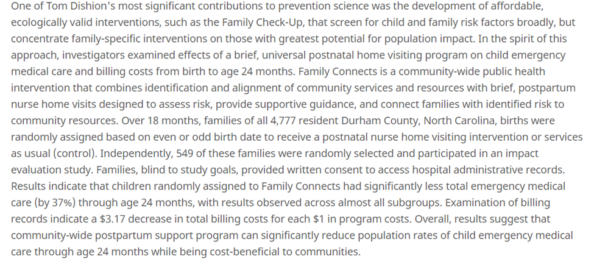

Bronstein, L., Gould, P., Berkowitz, S., James, G., & Marks, K. (2015). Impact of a social work care coordination intervention on hospital readmission: A randomized controlled trial. Soc Work, 60(3), 248-255. Doi: 10.1093/sw/swv016. Retrieved from https://www.ncbi.nlm.nih.gov/pubmed/26173366.

Social work-led care coordination designed to identify and alleviate barriers to patients remaining at home post-hospital discharge. Positive patient response to intervention; positive change in post-discharge risk for 30 day hospital readmission.

Smith, R., Dobbins, S., Evans, A., Balhotra, K., & Dicker, R. (2013). Hospital-based violence intervention: Risk reduction resources that are essential for success. J Trauma Acute Care Surg, 74(4), 976-980. Doi: 10.1097/TA.0b013e31828586c9. Retrieved from https://www.ncbi.nlm.nih.gov/pubmed/23511134.

The Wraparound project, hospital-based case management program targeting violently injured youth. Culturally competent case managers create risk reduction plan and shepherd clients through community resources. Positive identification of unmet needs; program success associated with meeting mental health and employment needs, as well as moderate and high intensive case management exposure in the first 3 months. Decline in recidivism for re-injuries.

Sege, R., Preer, G., Morton, S., Cabral, H., Morakinyo, O., Lee, V., Abreu, C., De Vos, E., & Kaplan-Sanoff, M. (2015). Medical-legal strategies to improve infant health care: A randomized trial. Pediatrics, 136(1), 97-106. Doi: 10.1542/peds.2014-2955.

DULCE - Developmental Understanding and Legal Collaboration for Everyone, a program engaging family specialists to conduct needs assessments and work directly with families to provide connections to resources. Positive increase in access to attainable concrete supports (food, public benefits, discounted telephone services); no difference in access to supports deemed unattainable (i.e. housing); Positive increase in preventive care for infants; Decreased ED visit by 6 months for infant.

Systematic Reviews

Fraze, T., Beidler, L, Briggs, A., & Colla, C. (2019). ‘Eyes in the home’: ACOs use home visits to improve care management, identify needs, and reduce hospital use. Health Affairs, 38(6), 1021-1027. Doi: 10.1377/hlthaff.2019.00003. Retrieved from https://www.healthaffairs.org/doi/full/10.1377/hlthaff.2019.00003

Study examining the National Survey of Healthcare Organizations and Systems to determine whether ACO practices were more likely to use care transition home visits than non-ACOs. Along with qualitative interviews of ACO leaders. Practices in ACOs were more likely to use post discharge care transition home visits for their complex patients (25.7% vs 18.8%); these practices had more primary care physicians as well as specialist physicians; they were more likely to be part of an integrated delivery system and include a hospital; as well as be a part of episode-based payment and other risk-bearing contracts. Findings suggest that ACO's are responsible for the quality and cost of services to patients, even those that don't adhere to medical guidelines, so tracking those patients down and using home visits as a tool to engage patients and discover barriers is common. However, there was a disconnect between the survey responses for home visits from ACO's and interview responses from ACO leadership, suggestion a gap in the knowledge from leadership on how these programs are implemented.

Gottlieb, L., Wing, H., & Adler, N. (2017). A systematic review of interventions on patients’ social and economic needs. AM J Prev Med, 53(5), 719-729. Doi: 10.1016/j.amepre.2017.05.011. Retrieved from https://www.ncbi.nlm.nih.gov/pubmed/28688725

A systematic review of the literature on interventions to address patients' social and economic needs. Review from 2000-2017, studies were based in the U.S.; addressed at least one social or economic determinant; were integrated into a medical care delivery system. More studies reporting findings associated with process (69%); or social or economic determinants of health (48%) outcomes than health (30%) or healthcare utilization or cost (27%) outcomes. Studies reporting health, utilization or cost outcomes reported mixed results.

Horwitz, L., Chang, C., Arcilla, H., & Knickman, J. (2020). Quantifying health systems’ investment in social determinants of health, by sector, 2017-19. Health Affairs, 39(2), 192-198. Doi: 10.1377/hlthaff.2019.01246. Retrieved from https://www.healthaffairs.org/doi/pdf/10.1377/hlthaff.2019.01246

A systematic review of the dollars US health systems are directly investing in community programs to address social determinants of health. Identified 78 unique programs involving 57 health systems that collectively included 917 hospitals. The programs involved at least $2.5 billion of health system funds, of which $1.6 billion in 52 programs was specifically committed to housing-focused interventions; employment programs (28) was $1.1 billion; education program (14) was $476.4 million; food security programs (25) was $294.2 million; social and community context (13) was $253.1 million; and transportation (6) was $32 million.

Ruiz, S., Snyder, L., Rotondo, C., Cross-Barnet, C., Colligan, E. & Giuriceo, K. (2017). Innovative home visit models associated with reductions in costs, hospitalizations, and emergency department use. Health Affairs, 36(3), 425-432. Doi: 10.1377/hlthaff.2016.1305. Retrieved from https://www.healthaffairs.org/doi/10.1377/hlthaff.2016.1305.

Review of five home health models to coordinate care for various patients:
- ABC Model (Aging Brain Care) - provides individualized and integrated care management through interdisciplinary care teams - monthly or quarterly home visits; Assesses patients' health status, monitors medications and adherence, delivers certain care protocols, offers environmental assessment, serves as liaison between the patient and other care team members. Over 3 year period – reduced hospitalizations.

-CAPABLE - (Community Aging in Place) Delivers a tailored combination of services to older adults who are dual Medicaid/Medicare beneficiaries; 10 home visits over a 5 month period; Assesses participants' functional difficulties, pain, depression and home environment; provides referrals to home and community-based services; and home modifications that allow seniors to age in place. Over 2 year period, reduced ED visits; reduced Medicare Expenditures.

-Stroke Mobile - Provides home-based follow up care once per month for a year after discharge from hospital for stroke, and targets stroke education for participants and their families caregivers. Offers educational modules to participants and family members/caregivers to address post-stroke care, prevention of additional strokes. Over 2 year period, reduced hospitalizations.
-DASH -(Doctors Assisting Seniors at Home) offers two-part episodic care coordination for Medicare and dual eligible who want to remain at home; Uses home-based assessment by nurses and follow up by nurse practitioners/physicians, preempts the need for emergency services; while conducting advanced care planning, medication reconciliation, receiving referrals for home and community-based services, and confirming connection to primary care physician. Over 3 year period – reduced hospitalizations; reduced ED visits; reduced Medicare expenditures.

-AIM - (Advanced Illness Management) Provides care coordination among hospital, home health care, physician's office, and telephone support for patients with late-stage illness. Weekly or biweekly home visits over 6-8 weeks. Enables patients to remain at home if they do not qualify for Medicare skilled home health care; visits provide engagement and education, advance care planning, medication reconciliation, assessment of patients' health status, navigation services, and referrals for durable medical equipment and home and community-based services. In last month of life, over a 3 year period – reduction in hospitalizations and Medicare expenditures.

Jack, H., Arabadjis, S., Sun, L., Sullivan, E. & Phillips, R. (2017). Impact of community health workers on use of healthcare services in the United States: A systematic review. J Gen Intern Med, 32(3), 325-344. Doi: 10.1007/s11606-016-3922-9. Retrieved from https://www.ncbi.nlm.nih.gov/pmc/articles/PMC5331010/.

Systematic review of Community Health Worker programs on healthcare issues and costs. Studies used Community Health Workers to connect adults with social services such as food, housing, transportation or insurance coverage, among other health interventions. 3 of 7 studies reported significant reductions in ED visits; 3 of 6 studies reported significant reductions in hospital use; 4 of 5 studies reported an increase in ambulatory care.

Appendix 7: Scenarios for Sharing CAPGI with private investors (CAPGI Excel Attachment #2)

George Mason University and Urban Institute
Harvard University
Altarum Institute
Former HCA Capital Division Chief Medical Officer, Richmond, Virginia.
Hedyah Mobahi, GMU Ph.D. student in HSR/HIT, deserves credit for writing the code in HTML and WordPress incredibly quickly from Len’s description of desired elements. Chanup Jeung, who just finished his HSR Ph.D. at GMU and was Len’s research assistant, maintained the site and helped Len edit it after creation. The site will migrate to the Urban Institute with Len and can be found at https://capgi.urban.org after June 1.
https://www.neighborhoodatlas.medicine.wisc.edu/
https://svi.cdc.gov/Documents/Data/2014_SVI_Data/SVI2014Documentation.pdf
https://opportunityindex.org/methods-sources/
https://aese.psu.edu/nercrd/community/social-capital-resources
https://www.census.gov/topics/income-poverty/poverty/guidance/poverty-measures.html
Which included all co-authors of this report and two very able GMU research assistants, Chanup Jeung and Ana Ramon Albors.
It will always be necessary and wise to evaluate the CAPGI implementation process, should implementations proceed. However, some upstream interventions have had numerous rigorous evaluations already (e.g., Housing First, Family Connects, etc), so there is no need and little appetite to conduct another randomized evaluation of the latest example intervention per se.
All four policy pathways are designed to enable SDOH spending to be included in the medical loss ratio or at least count as permissible spending when computing MCO rates: (1) just define the intervention in question as “in lieu of” medical service in the state’s MCO RFP; (2) declare the upstream services as “value added” and while not in MLR technically, they can still count as allowable spending and thus de facto paid for with Medicaid program dollars; (3) include the intervention in the requirements for a value based payment arrangement; (4) increase the allowable profit rate in MCO payment rates in exchange for a commitment to spend that much (at least) on SDOH intervention(s).
Altarum, https://altarum.org/news/lower-personal-consumption-expenditures-driven-by-health-care-spending

